**COMPUTER NETWORK**

**Unit :- 1**

* **Representation of Data/Information**

Computer does not understand human language. Any data, viz., letters, symbols, pictures, audio, videos, etc., fed to computer should be converted to machine language first. Computers represent data in the following three forms –

## **Number System**

We are introduced to concept of numbers from a very early age. To a computer, everything is a number, i.e., alphabets, pictures, sounds, etc., are numbers. Number system is categorized into four types −

* Binary number system consists of only two values, either 0 or 1
* Octal number system represents values in 8 digits.
* Decimal number system represents values in 10 digits.
* Hexadecimal number system represents values in 16 digits.

|  |  |  |
| --- | --- | --- |
| **Number System** | | |
| **System** | **Base** | **Digits** |
| Binary | 2 | 0 1 |
| Octal | 8 | 0 1 2 3 4 5 6 7 |
| Decimal | 10 | 0 1 2 3 4 5 6 7 8 9 |
| Hexadecimal | 16 | 1. 1 2 3 4 5 6 7 8 9 A B C D E F |

## **2 .Bits and Bytes**

**Bits** − A bit is a smallest possible unit of data that a computer can recognize or use. Computer usually uses bits in groups.

**Bytes** − group of eight bits is called a byte. Half a byte is called a nibble.

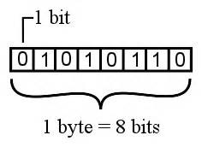

## **3.Text Code**

Text code is format used commonly to represent alphabets, punctuation marks and other symbols. Four most popular text code systems are −

* EBCDIC
* ASCII
* Extended ASCII
* Unicode
* **DATA FLOW :-**

With dataflow we can communicate with other person from one place to other place .

**Types of Data Flow :-**

**1. Simplex:**

In simplex mode, the communication is unidirectional, as on a one-way street. Only one of the two devices on a link can transmit; the other can only receive which can be represented in the following figure.

Examples of simplex :- include radio broadcasting, television broadcasting, computer to printer communication, and keyboard to computer connections.

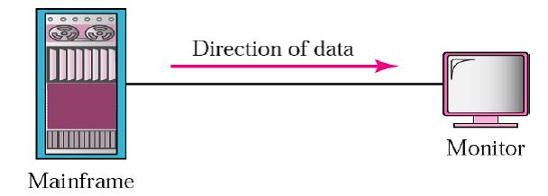

**2.Half-Duplex:**

In half-duplex mode, each station can both transmit and receive, but not at the same time. When one device is sending, the other can only receive, and vice versa which will represent in the following figure.

Ex :- Walkie Talkie.

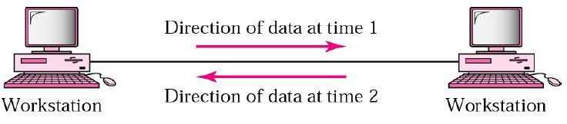

**3.Full-Duplex:**

In full-duplex mode (also called duplex), both stations can transmit and receive simultaneously as shown in the following figure.

Ex :- Mobile

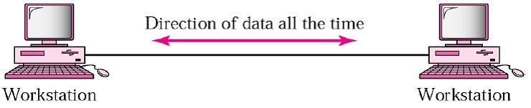

* **VERIOUS CONNECTION TOPOLOGY :-**

A Network Topology is the arrangement with which computer systems or network devices are connected to each other. Topologies may define both physical and logical aspect of the network. Both logical and physical topologies could be same or different in a same network.

## **Point-to-Point :-**

Point-to-point networks contains exactly two hosts such as computer, switches or routers, servers connected back to back using a single piece of cable. Often, the receiving end of one host is connected to sending end of the other and vice-versa.

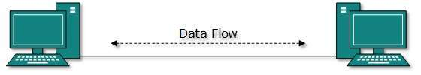

## **Bus Topology :-**

In case of Bus topology, all devices share single communication line or cable.Bus topology may have problem while multiple hosts sending data at the same time. Therefore, Bus topology either uses CSMA/CD technology or recognizes one host as Bus Master to solve the issue. It is one of the simple forms of networking where a failure of a device does not affect the other devices. But failure of the shared communication line can make all other devices stop functioning.

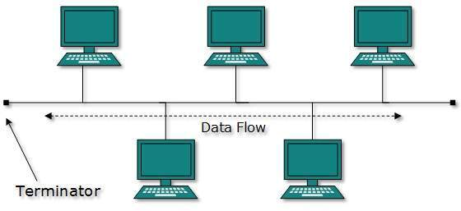

## **Star Topology**

All hosts in Star topology are connected to a central device, known as hub device, using a point-to-point connection. That is, there exists a point to point connection between hosts and hub. The hub device can be any of the following:

* Layer-1 device such as hub or repeater
* Layer-2 device such as switch or bridge
* Layer-3 device such as router or gateway

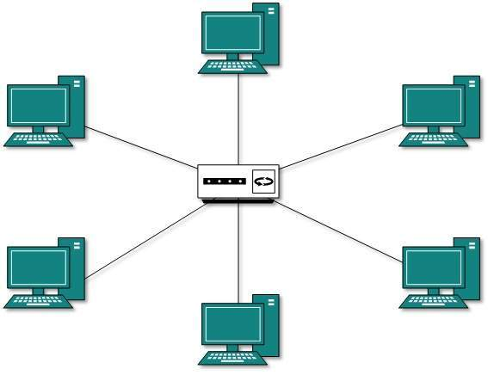

## **Ring Topology**

In ring topology, each host machine connects to exactly two other machines, creating a circular network structure. When one host tries to communicate or send message to a host which is not adjacent to it, the data travels through all intermediate hosts. To connect one more host in the existing structure, the administrator may need only one more extra cable.

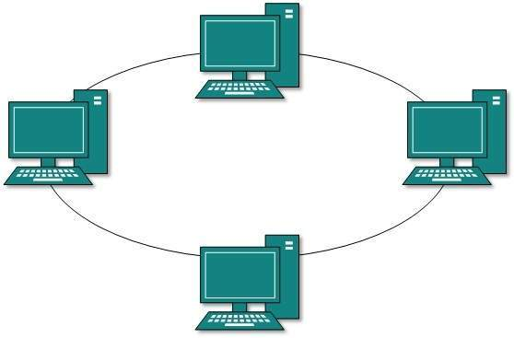

## **Mesh Topology**

In this type of topology, a host is connected to one or multiple hosts.This topology has hosts in point-to-point connection with every other host or may also have hosts which are in point-to-point connection to few hosts only.

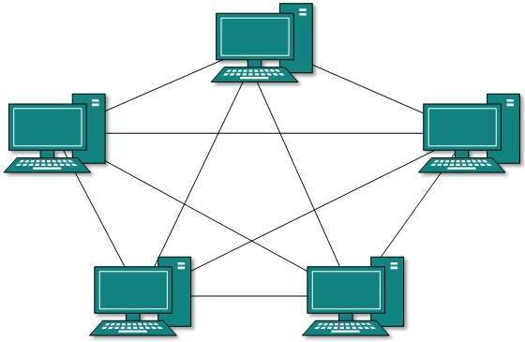

**Mesh technology comes into two types:**

* **Full Mesh**: All hosts have a point-to-point connection to every other host in the network. Thus for every new host n(n-1)/2 connections are required. It provides the most reliable network structure among all network topologies.
* **Partially Mesh**: Not all hosts have point-to-point connection to every other host. Hosts connect to each other in some arbitrarily fashion. This topology exists where we need to provide reliability to some hosts out of all.

## **Tree Topology**

Also known as Hierarchical Topology, this is the most common form of network topology in use presently.This topology imitates as extended Star topology and inherits properties of bus topology.

This topology divides the network in to multiple levels/layers of network. Mainly in LANs, a network is bifurcated into three types of network devices. The lowermost is access-layer where computers are attached. The middle layer is known as distribution layer, which works as mediator between upper layer and lower layer. The highest layer is known as core layer, and is central point of the network, i.e. root of the tree from which all nodes fork.

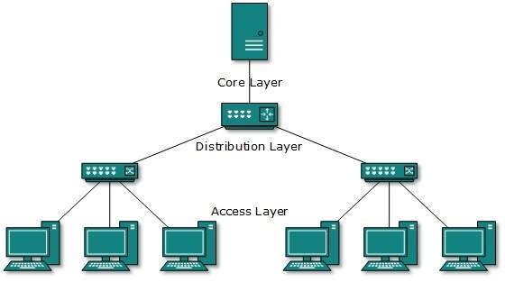

## **Daisy Chain**

This topology connects all the hosts in a linear fashion. Similar to Ring topology, all hosts are connected to two hosts only, except the end hosts.Means, if the end hosts in daisy chain are connected then it represents Ring topology.

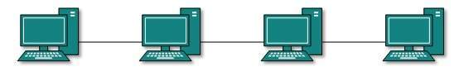

## **Hybrid Topology**

A network structure whose design contains more than one topology is said to be hybrid topology. Hybrid topology inherits merits and demerits of all the incorporating topologies.

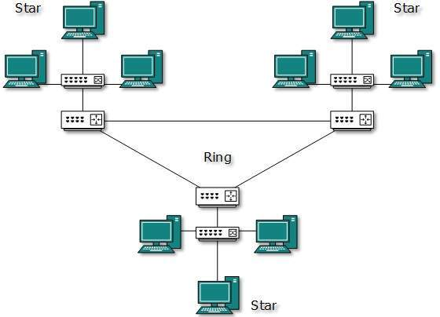

* **PROTOCOL AND STANDARD**
* **Protocol :**  
  In Order to make communication successful between devices , some rules and procedures should be agreed upon at the sending and receiving ends of the system. Such rules and procedures are called as Protocols . Different types of protocols are used for different types of communication.
* 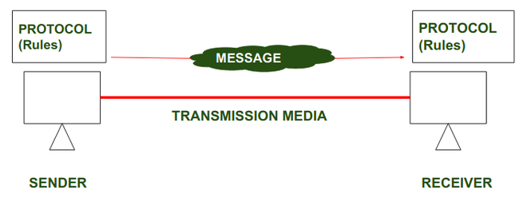

### **Types of protocols :-**

The protocols can be broadly classified into three major categories-

1. Communication
2. Management
3. Security

### **1. Communication**

Communication protocols are really important for the functioning of a network. They are so crucial that it is not possible to have computer networks without them. These protocols formally set out the rules and formats through which data is transferred. These protocols handle syntax, semantics, error detection, synchronization, and authentication.

* **TTP**
* **TCP**
* **UDP**
* **BGP**
* **ARP**

### **2. Manageme :-** These protocols also help in communicating these requirements across the network to ensure stable communication. Network management protocols can also be used for troubleshooting connections between a host and a client.

* **ICMP**
* **SNMP**
* **GOPHER**
* **FTP**

### **3. Security**

These protocols secure the data in passage over a network. These protocols also determine how the network secures data from any unauthorized attempts to extract or review data. These protocols make sure that no unauthorized devices, users, services can access the network data. Primarily, these protocols depend on encryption to secure data.

**Examples of Security Protocols:**

* **SSL**
* **HTTPS**
* **TSL**
* **STANDARDS :-**

Standards are the set of rules  for data communication that are needed for  exchange of information among devices. It is important to follow Standards which are created by various  Standard Organization like IEEE , ISO , ANSI etc.

**Types of Standards :**

Standards are of two types :

* De Facto Standard.
* De Jure  Standard.

**De Facto Standard : -** The meaning of the work *” De Facto ”* is ” By Fact ”  or “By Convention”.  
These are the standard s that have not been approved by any Organization , but have been adopted as  Standards  because of it’s widespread use. Also , sometimes these standards are often established by Manufacturers.

**For example :** Apple  and Google are two companies which established their own rules on their products which are different . Also they use some same standard rules for manufacturing for their products.

**De Jure Standard : -** The meaning of the word *“De Jure”* is  “By Law” or “By  Regulations” .   
Thus , these are the  standards that have been approved by officially recognized body like ANSI , ISO , IEEE etc. These are the standard which are important to follow if it is required or needed.

**For example :** All the data communication standard  protocols like SMTP , TCP , IP , UDP etc. are important to follow the same when we needed them.

# OSI Model

The OSI (Open Systems Interconnection) model is developed by the International Standard Organization. It is a layered framework for the design of network systems that allows communication between all types of computer systems. Its primary purpose is to provide a set of structural guidelines for exchanging information between computers, workstations, and networks.

## OSI Model in Computer Networks - Studyopedia

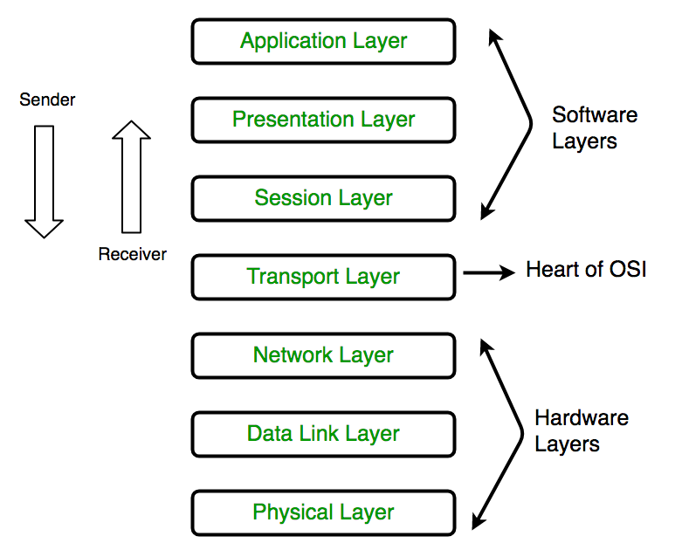

### **1. Physical Layer (Layer 1) :**

The lowest layer of the OSI reference model is the physical layer. It is responsible for the actual physical connection between the devices. The physical layer contains information in the form of**bits.** It is responsible for transmitting individual bits from one node to the next. When receiving data, this layer will get the signal received and convert it into 0s and 1s and send them to the Data Link layer, which will put the frame back together.

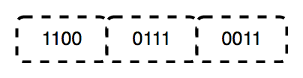

The functions of the physical layer are as follows:

1. **Bit synchronization:** The physical layer provides the synchronization of the bits by providing a clock. This clock controls both sender and receiver thus providing synchronization at bit level.
2. **Bit rate control:** The Physical layer also defines the transmission rate i.e. the number of bits sent per second.
3. **Physical topologies:** Physical layer specifies the way in which the different, devices/nodes are arranged in a network i.e. bus, star, or mesh topology.
4. **Transmission mode:** Physical layer also defines the way in which the data flows between the two connected devices. The various transmission modes possible are Simplex, half-duplex and full-duplex.

* Hub, Repeater, Modem, Cables are Physical Layer devices.

** Network Layer, Data Link Layer, and Physical Layer are also known as **Lower Layers** or **Hardware Layers**.

### **2. Data Link Layer (DLL) (Layer 2) :**

The data link layer is responsible for the node-to-node delivery of the message. The main function of this layer is to make sure data transfer is error-free from one node to another, over the physical layer. When a packet arrives in a network, it is the responsibility of DLL to transmit it to the Host using its MAC address.   
Data Link Layer is divided into two sublayers:

1. Logical Link Control (LLC)
2. Media Access Control (MAC)

The packet received from the Network layer is further divided into frames depending on the frame size of NIC(Network Interface Card). DLL also encapsulates Sender and Receiver’s MAC address in the header.

The Receiver’s MAC address is obtained by placing an ARP(Address Resolution Protocol) request onto the wire asking “Who has that IP address?” and the destination host will reply with its MAC address.

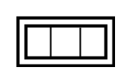

The functions of the Data Link layer are :

1. **Framing:**Framing is a function of the data link layer. It provides a way for a sender to transmit a set of bits that are meaningful to the receiver. This can be accomplished by attaching special bit patterns to the beginning and end of the frame.
2. **Physical addressing:** After creating frames, the Data link layer adds physical addresses (MAC address) of the sender and/or receiver in the header of each frame.
3. **Error control:** Data link layer provides the mechanism of error control in which it detects and retransmits damaged or lost frames.
4. **Flow Control:** The data rate must be constant on both sides else the data may get corrupted thus, flow control coordinates the amount of data that can be sent before receiving acknowledgement.
5. **Access control:**When a single communication channel is shared by multiple devices, the MAC sub-layer of the data link layer helps to determine which device has control over the channel at a given time.

*\* Packet in Data Link layer is referred to as* ***Frame.***

** Data Link layer is handled by the NIC (Network Interface Card) and device drivers of host machines.

*** Switch & Bridge are Data Link Layer devices.

### **3. Network Layer (Layer 3) :**

The network layer works for the transmission of data from one host to the other located in different networks. It also takes care of packet routing i.e. selection of the shortest path to transmit the packet, from the number of routes available. The sender & receiver’s IP addresses are placed in the header by the network layer.

The functions of the Network layer are :

1. **Routing:** The network layer protocols determine which route is suitable from source to destination. This function of the network layer is known as routing.
2. **Logical Addressing:**In order to identify each device on internetwork uniquely, the network layer defines an addressing scheme. The sender & receiver’s IP addresses are placed in the header by the network layer. Such an address distinguishes each device uniquely and universally.

*\* Segment* in Network layer is referred to as **Packet**.



** Network layer is implemented by networking devices such as routers.

### **4. Transport Layer (Layer 4) :**

The transport layer provides services to the application layer and takes services from the network layer. The data in the transport layer is referred to as *Segments*. It is responsible for the End to End Delivery of the complete message. The transport layer also provides the acknowledgement of the successful data transmission and re-transmits the data if an error is found.

**At sender’s side:**Transport layer receives the formatted data from the upper layers, performs **Segmentation**, and also implements **Flow & Error control** to ensure proper data transmission. It also adds Source and Destination port numbers in its header and forwards the segmented data to the Network Layer.

***Note:****The sender needs to know the port number associated with the receiver’s application.*

Generally, this destination port number is configured, either by default or manually. For example, when a web application makes a request to a web server, it typically uses port number 80, because this is the default port assigned to web applications. Many applications have default ports assigned.

**At receiver’s side:** Transport Layer reads the port number from its header and forwards the Data which it has received to the respective application. It also performs sequencing and reassembling of the segmented data.

The functions of the transport layer are as follows:

1. **Segmentation and Reassembly:** This layer accepts the message from the (session) layer, and breaks the message into smaller units. Each of the segments produced has a header associated with it. The transport layer at the destination station reassembles the message.
2. **Service Point Addressing:** In order to deliver the message to the correct process, the transport layer header includes a type of address called service point address or port address. Thus by specifying this address, the transport layer makes sure that the message is delivered to the correct process.

The services provided by the transport layer :

**A. Connection-Oriented Service:** It is a three-phase process that includes

– Connection Establishment   
– Data Transfer   
– Termination / disconnection

In this type of transmission, the receiving device sends an acknowledgement, back to the source after a packet or group of packets is received. This type of transmission is reliable and secure.

**B. Connectionless service:** It is a one-phase process and includes Data Transfer. In this type of transmission, the receiver does not acknowledge receipt of a packet. This approach allows for much faster communication between devices. Connection-oriented service is more reliable than connectionless Service.

*\* Data in the Transport Layer is called as****Segments****.*  
*\*\* Transport layer is operated by the Operating System. It is a part of the OS and communicates with the Application Layer by making system calls.*  
*Transport Layer is called as****Heart of OSI****model.*

### **5. Session Layer (Layer 5) :**

This layer is responsible for the establishment of connection, maintenance of sessions, authentication, and also ensures security.   
The functions of the session layer are :

1. **Session establishment, maintenance, and termination:** The layer allows the two processes to establish, use and terminate a connection.
2. **Synchronization:** This layer allows a process to add checkpoints which are considered synchronization points into the data. These synchronization points help to identify the error so that the data is re-synchronized properly, and ends of the messages are not cut prematurely and data loss is avoided.
3. **Dialog Controller:** The session layer allows two systems to start communication with each other in half-duplex or full-duplex.

*\*\*All the below 3 layers(including Session Layer) are integrated as a single layer in the TCP/IP model as “Application Layer”.*  
*\*\*Implementation of these 3 layers is done by the network application itself. These are also known as****Upper Layers****or****Software Layers****.*

### Scenario:

Let us consider a scenario where a user wants to send a message through some Messenger application running in his browser. The “Messenger” here acts as the application layer which provides the user with an interface to create the data. This message or so-called Data is compressed, encrypted (if any secure data), and converted into bits (0’s and 1’s) so that it can be transmitted.

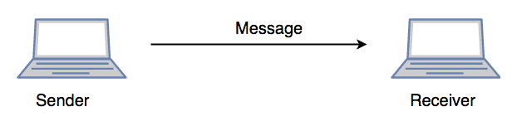

### **6. Presentation Layer (Layer 6):**

The presentation layer is also called the **Translation layer**. The data from the application layer is extracted here and manipulated as per the required format to transmit over the network.   
The functions of the presentation layer are :

* **Translation:** For example, ASCII to EBCDIC.
* **Encryption/ Decryption:** Data encryption translates the data into another form or code. The encrypted data is known as the ciphertext and the decrypted data is known as plain text. A key value is used for encrypting as well as decrypting data.
* **Compression:** Reduces the number of bits that need to be transmitted on the network.

### **7. Application Layer (Layer 7) :**

At the very top of the OSI Reference Model stack of layers, we find the Application layer which is implemented by the network applications. These applications produce the data, which has to be transferred over the network. This layer also serves as a window for the application services to access the network and for displaying the received information to the user.

Example: Application – Browsers, Skype Messenger, etc.

*\*\*Application Layer is also called Desktop Layer.*

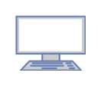

The functions of the Application layer are :

1. Network Virtual Terminal
2. FTAM-File transfer access and management
3. Mail Services
4. Directory Services

**OSI model** acts as a reference model and is not implemented on the Internet because of its late invention. The current model being used is the TCP/IP model.

**OSI model in a nutshell**

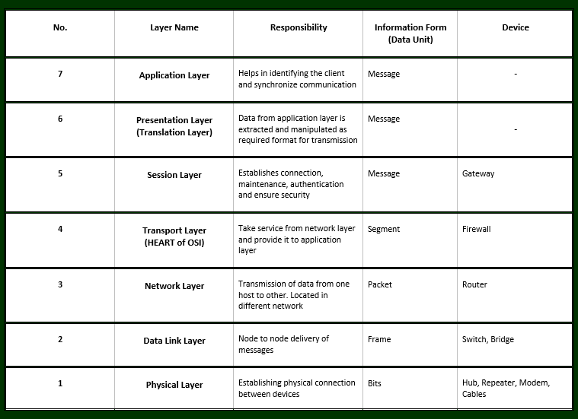

## **Transmission Media**

Transmission media is a communication channel that transmits information from the source/transmitter to the receiver. It is a physical path for data transfer through electromagnetic signals. Information is carried over in the form of bits through [LAN](https://www.naukri.com/learning/articles/lan-local-area-network/). It can mediate the propagation of signals for telecommunication.

## Types of Transmission Media in Computer Networks

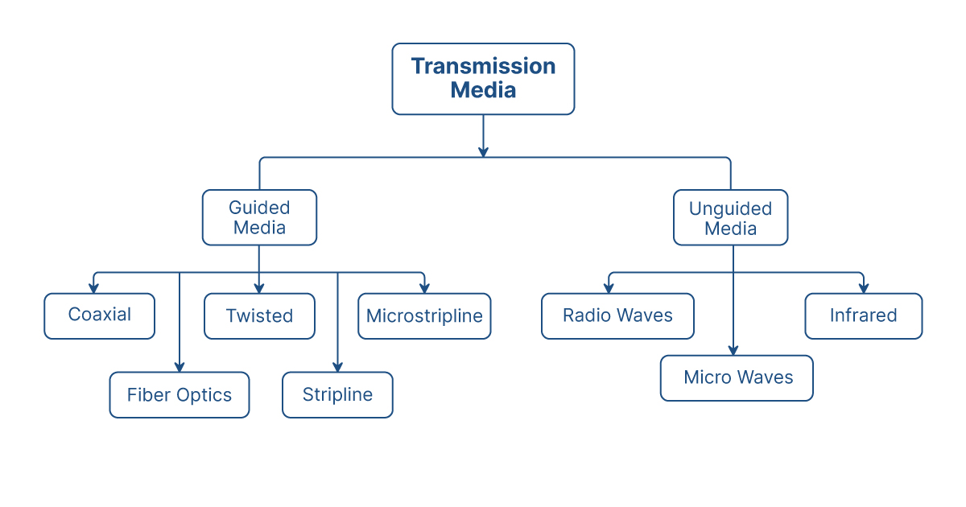

 there are two types of transmission media in [computer networks](https://www.naukri.com/learning/articles/types-of-computer-networks/) including guided and unguided media. These two types of transmission media have further subtypes.

## **1. Guided Transmission Media**

Guided media are also known as wired or bounded media. These media consist of wires through which the data is transferred. Guided media is a physical link between transmitter and recipient devices. Signals are directed in a narrow pathway using physical links. These media types are used for shorter distances since physical limitation limits the signal that flows through these transmission media.

### **1.1 Twisted Pair Cable**

In this type of transmission media, two insulated conductors of a single circuit are twisted together to improve electromagnetic compatibility.

### **1. 2 Optical Fibre Cable**

Also known as fiber optic cable, these are thin strands of glass that guide light along their length. These contain multiple optical fibers and are very often used for long-distance communications.

### **1.3 Coaxial cable**

These guided transmission media contain an insulation layer that transmits information in baseband mode and broadband mode

### **1.4 Stripline**

This is a  transverse electromagnetic (TEM) transmission media that is built on the inner layers of multi-layer printed circuit boards. These are used in high or low-level RF signals that require isolation from surrounding circuitry.

### **1.5 Microstripline**

While Microstripline is simiar to stripline, it is not sandwiched and are present above the ground plane.

## **2. Unguided Transmission Media**

Also known as unbounded or wireless media, they help in transmitting electromagnetic signals without using a physical medium. Here, air is the medium. There is no physical connectivity between transmitter and receiver. These types of transmission media are used for longer distances however they are less secure than guided media. There are three main types of wireless transmission media.

### **2.1  Radio Waves**

Radio waves are transmitted in every direction throughout free space. Since these are omnidirectional, sent waves can be received by any antenna. These waves are useful when the data is to multicasted from one sender to multiple receivers. Radio waves can cover large areas and even penetrate obstacles such as buildings and walls.

EX :- Mobile , Radio.

### **2.2 Infrared**

These waves are useful for only very short distance communication. Unlike radio waves, they do not have the ability to penetrate barriers. Their range varies between 300GHz – 400THz.

EX :- Remote Control.

### **2.3 Microwaves**

For these waves, it is important for the transmitter and receiver antenna to be aligned. This is why it is known as line-of-sight transmission. Due to this, they are suitable for shorter distances. They comprise of electromagnetic waves with frequencies ranging between 1-400 GHz. Microwaves provide bandwidth between the range of 1 to 10 Mbps.

Ex:- GPS , WI-FI , BLUETOOTH.

# Local Area Networks:-

A Local Area Network (LAN) is a private network that connects computers and devices within a limited area like a residence, an office, a building or a campus. On a small scale, LANs are used to connect personal computers to printers. However, LANs can also extend to a few kilometers when used by companies, where a large number of computers share a variety of resources like hardware (e.g. printers, scanners, audiovisual devices etc), software (e.g. application programs) and data.

## **The distinguishing features of LAN are**

* Network size is limited to a small geographical area, presently to a few kilometers.
* Data transfer rate is generally high. They range from 100 Mbps to 1000 Mbps.
* In general, a LAN uses only one type of transmission medium, commonly category 5 coaxial cables.
* A LAN is distinguished from other networks by their topologies. The common topologies are bus, ring, mesh, and star.
* The number of computers connected to a LAN is usually restricted. In other words, LANs are limitedly scalable.

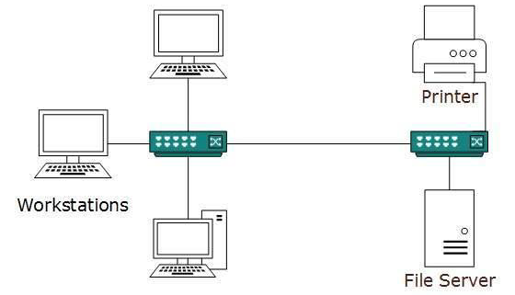

**There are two primary LAN types:**-

* **WIRED LANS**
* **Wireless LANs**

A **wired LAN** uses switches and Ethernet cabling to connect endpoints, servers and internet of things (IoT) devices to the corporate network. For small businesses with only a handful of devices, a wired LAN can consist of a single unmanaged LAN switch with enough Ethernet ports to interconnect all devices.

Example:-

**telephone networks, cable television or internet access, and fiber-optic communication**.

**Wireless LANs :-** (WLANs) are wireless computer networks that use high-frequency radio waves instead of cables for connecting the devices within a limited area forming LAN (Local Area Network). Users connected by wireless LANs can move around within this limited area such as home, school, campus, office building, railway platform, etc.

#### **Types of Computer Networks:-**

1. Personal Area Network (PAN)
2. Local Area Network (LAN)
3. Wide Area Network (WAN)
4. Wireless Local Area Network (WLAN)
5. Campus Area Network (CAN)
6. Metropolitan Area Network (MAN)
7. Storage Area Network (SAN)
8. System-Area Network (SAN)
9. Passive Optical Local Area Network (POLAN)

* **Personal Area Network (PAN)** :-  
  PAN is the most basic type of computer network. This network is restrained to a single person, that is, communication between the computer devices is centred only to an individual’s work space. PAN offers a network range of 10 meters from a person to the device providing communication.
* Examples of PAN are USB, computer, phone, tablet, printer, PDA, etc.
* 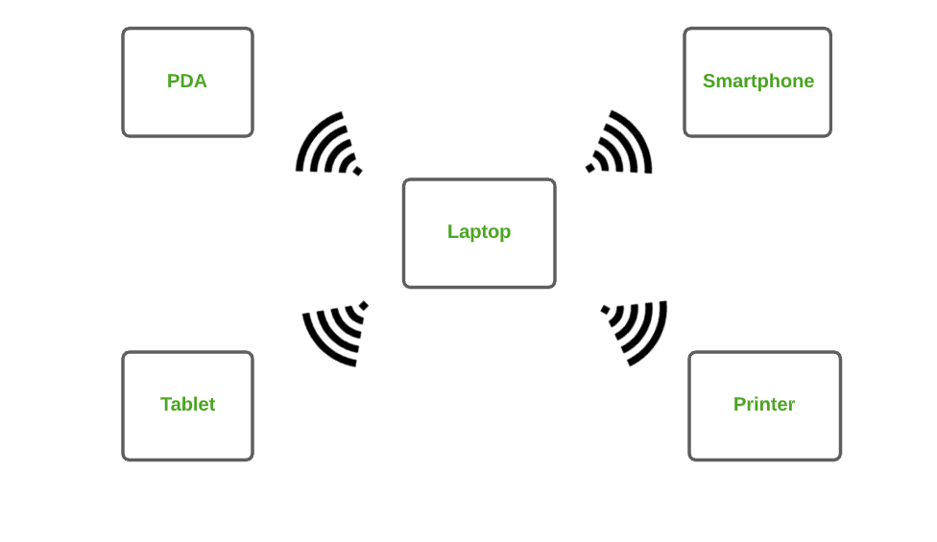

**2. Local Area Network (LAN) :**   
LAN is the most frequently used network. A LAN is a computer network that connects computers together through a common communication path, contained within a limited area, that is, locally. A LAN encompasses two or more computers connected over a server. The two important technologies involved in this network are Ethernet and Wi-fi.

Examples of LAN are networking in a home, school, library, laboratory, college, office, etc.

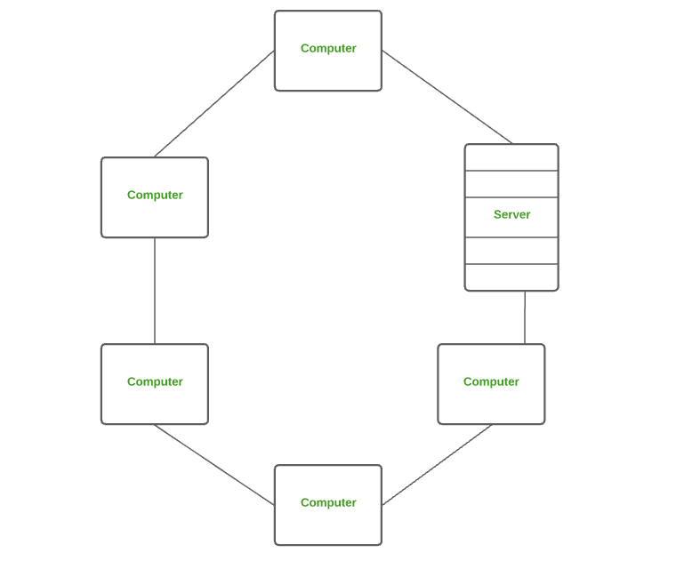

**3. Wide Area Network (WAN)** **:**  
WAN is a type of computer network that connects computers over a large geographical distance through a shared communication path. It is not restrained to a single location but extends over many locations. WAN can also be defined as a group of local area networks that communicate with each other.

The most common example of WAN is the Internet.

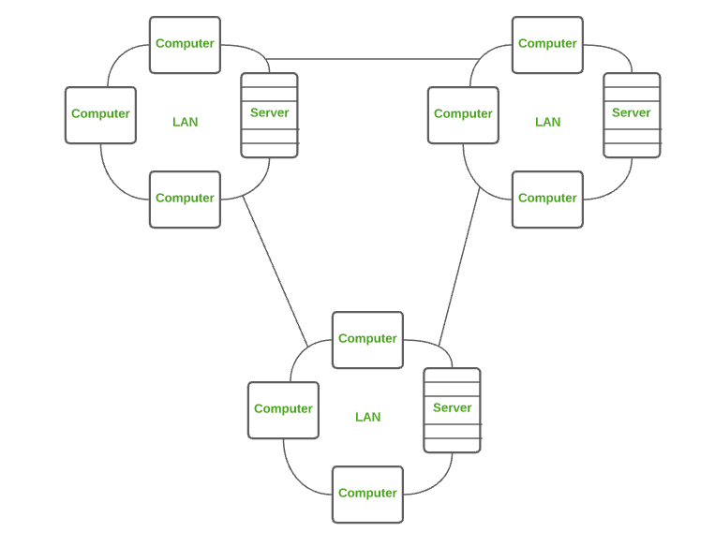

**5. Campus Area Network (CAN)** **:**  
CAN is bigger than a LAN but smaller than a MAN. This is a type of computer network which is usually used in places like a school or college. This network covers a limited geographical area that is, it spreads across several buildings within the campus.

Examples of CAN are networks that cover schools, colleges, buildings, etc.

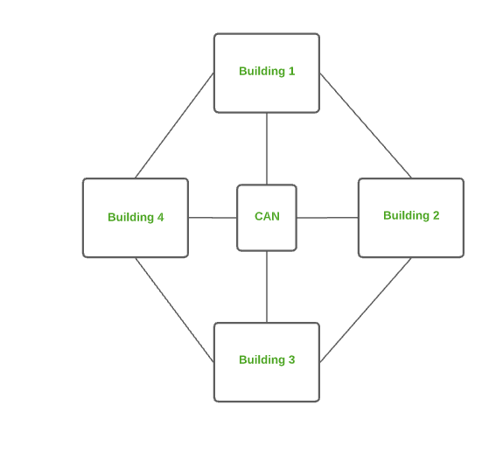

**6. Metropolitan Area Network (MAN)** **:**  
A MAN is larger than a LAN but smaller than a WAN. This is the type of computer network that connects computers over a geographical distance through a shared communication path over a city, town or metropolitan area.

Examples of MAN are networking in towns, cities, a single large city, large area within multiple buildings, etc.

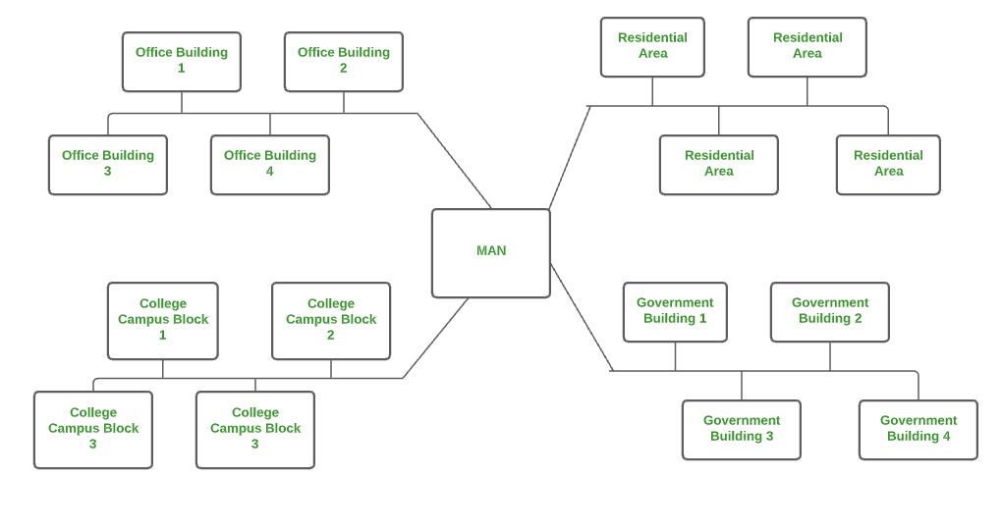

# Virtual LAN:-

**Virtual LAN (VLAN)** is a concept in which we can divide the devices logically on layer 2 (data link layer). Generally, layer 3 devices divide broadcast domain but broadcast domain can be divided by switches using the concept of VLAN.

A broadcast domain is a network segment in which if a device broadcast a packet then all the devices in the same broadcast domain will receive it.

## **Types of VLANs**

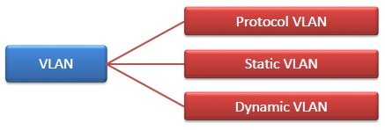

* **Protocol VLAN** − Here, the traffic is handled based on the protocol used. A switch or bridge segregates, forwards or discards frames the come to it based upon the traffics protocol.
* **Port-based VLAN** − This is also called static VLAN. Here, the network administrator assigns the ports on the switch / bridge to form a virtual network.
* **Dynamic VLAN** − Here, the network administrator simply defines network membership according to device characteristics.

## **Bandwidth:-**

Bandwidth is the data transfer capacity of a computer network in bits per second (Bps).

### **KEY TAKEAWAYS**

* Bandwidth is a measure of how much information a network can transfer.

## **Understanding Bandwidth**

Bandwidth is a measure of how much information a network, a group of two or more devices that communicate between themselves, can transfer. Data moves from A to B just as water flows through pipes from a supply point to our faucets. The volume that's transported, the bandwidth, varies, impacting how effectively a transmission medium, such as an Internet connection, operates.

[Internet service providers (ISPs)](https://www.investopedia.com/terms/i/isp.asp) typically denote bandwidth speeds in millions of bits per second (Bps), or megabits (Mbps), and billions of Bps, or gigabits (Gbps). Generally speaking, the higher the bandwidth, the quicker a computer downloads information from the Internet, including emails or streamed movies.

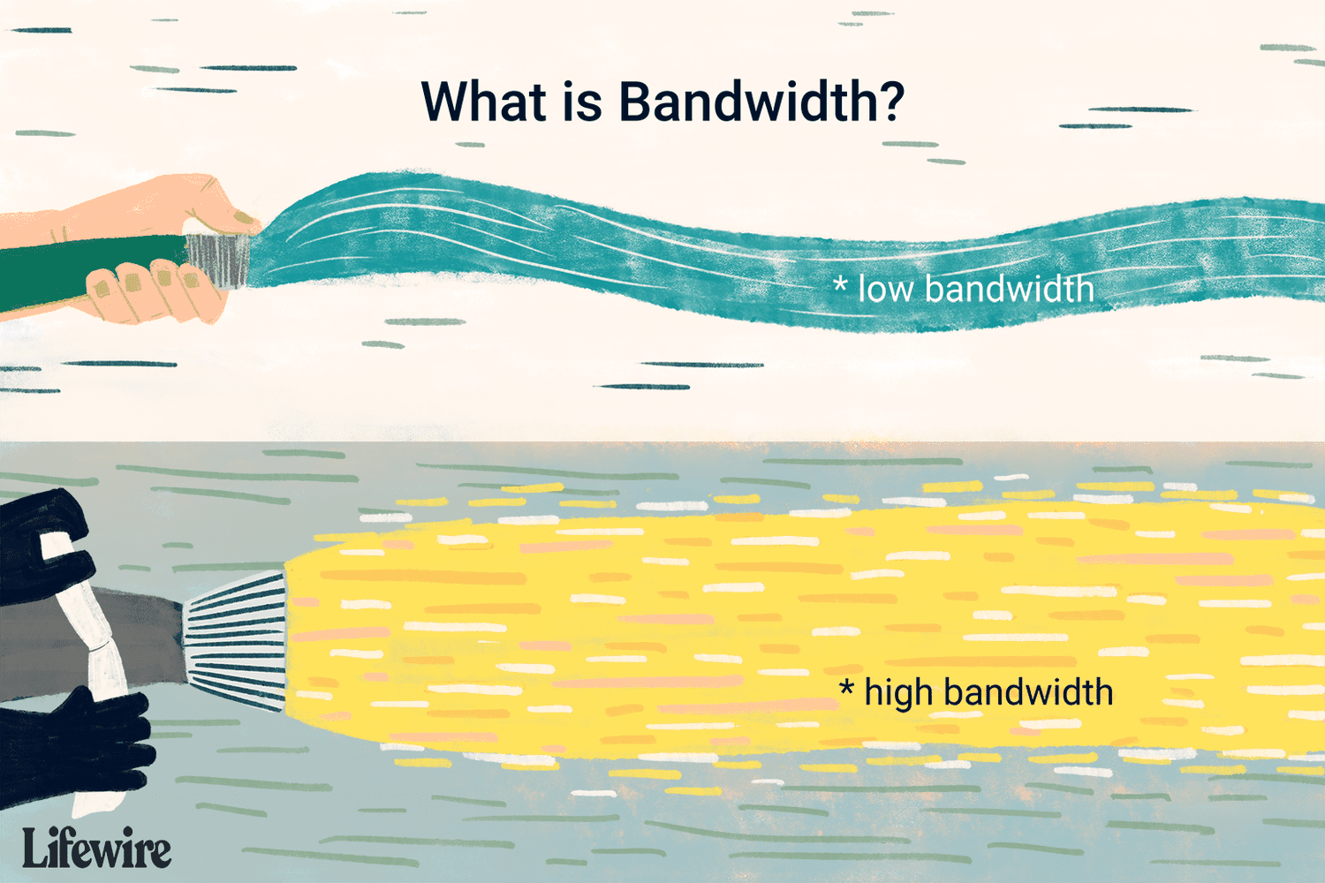

# Frequency Division Multiplexing (FDM):-

Frequency Division Multiplexing (FDM) is a networking technique in which multiple data signals are combined for simultaneous transmission via a shared communication medium. FDM uses a carrier signal at a discrete frequency for each data stream and then combines many modulated signals.  
  
When FDM is used to allow multiple users to share a single physical communications medium (i.e. not broadcast through the air), the technology is called frequency-division multiple access (FDMA).

It is use for electrical signal.

It is used in radio and TV transmission.

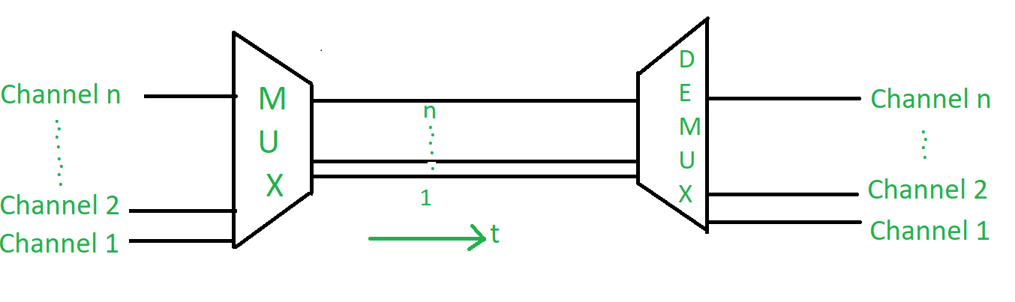

**Application of FDM:**

1. In the first generation of mobile phones, FDM was used.
2. The use of FDM in television broadcasting
3. FDM is used to broadcast FM and AM radio frequencies.

### **2. Time Division Multiplexing (TDM):**

This happens when the data transmission rate of media is greater than that of the source, and each signal is allotted a definite amount of time. These slots are so small that all transmissions appear to be parallel. In frequency division multiplexing all the signals operate at the same time with different frequencies, but in time-division multiplexing, all the signals operate with the same frequency at different times. 

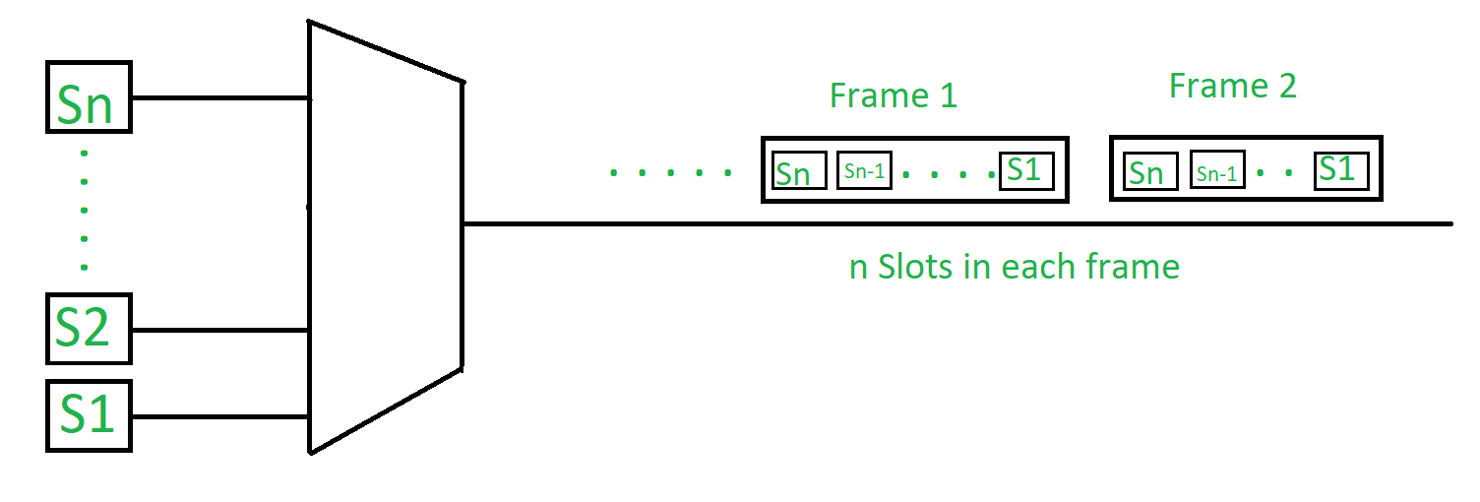

**1. Synchronous TDM:**

The time slots are pre-assigned and fixed. This slot is even given if the source is not ready with data at this time. In this case, the slot is transmitted empty. It is used for multiplexing digitized voice streams.

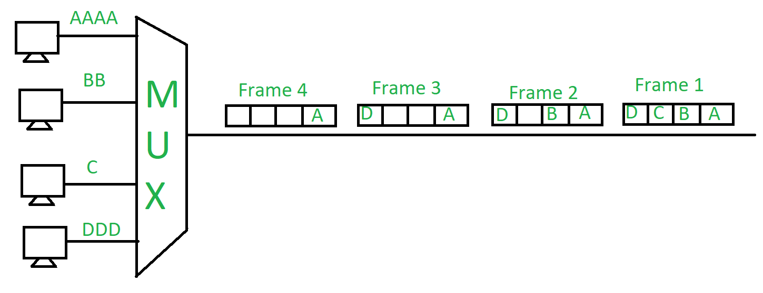

**2. Asynchronous (or statistical) TDM:**

The slots are allocated dynamically depending on the speed of the source or their ready state. It dynamically allocates the time slots according to different input channels’ needs, thus saving the channel capacity.

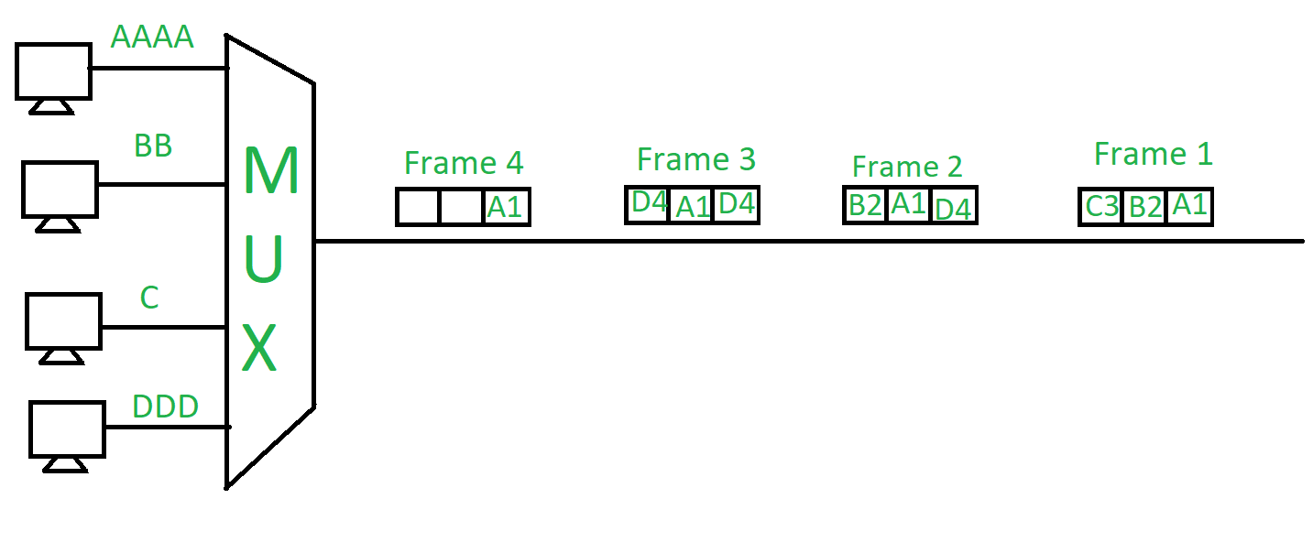

# Wavelength Division Multiplexing(WDM):-

Wavelength division multiplexing (WDM) is a technique of multiplexing multiple optical carrier signals through a single optical fiber channel by varying the wavelengths of laser lights. WDM allows communication in both the directions in the fiber cable.

## **Concept and Process**

In WDM, the optical signals from different sources or (transponders) are combined by a multiplexer, which is essentially an optical combiner. They are combined so that their wavelengths are different.

The combined signal is transmitted via a single optical fiber strand. At the receiving end, a demultiplexer splits the incoming beam into its components and each of the beams is send to the corresponding receivers.

## **Example**

The following diagram conceptually represents multiplexing using WDM. It has 4 optical signals having 4 different wavelengths. Each of the four senders generates data streams of a particular wavelength. The optical combiner multiplexes the signals and transmits them over a single long-haul fiber channel. At the receiving end, the splitter demultiplexes the signal into the original 4 data streams.

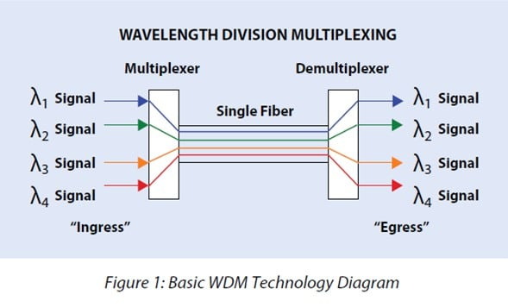

# Spread Spectrum in Mobile Computing:-

Spread spectrum is a technique used for wireless communications in telecommunication and radio communication. In this technique, the frequency of the transmitted signal, i.e., an electrical signal, electromagnetic signal, or acoustic signal, is deliberately varied and generates a much greater bandwidth than the signal would have if its frequency were not varied.

In other words, "Spread Spectrum is a technique in which the transmitted signals of specific frequencies are varied slightly to obtain greater bandwidth as compared to initial bandwidth."

## **Usage of Spread Spectrum:-**

There are many reasons to use this spread spectrum technique for wireless communications. The following are some reasons:

* It can successfully establish a secure medium of communication.
* It can limit the power flux density (e.g., in satellite down links).
* It can enable multiple-access communications.

## **Types of Spread Spectrum:-**

Spread Spectrum can be categorized into two types:

* Frequency Hopping Spread Spectrum (FHSS)
* Direct Sequence Spread Spectrum(DSSS)

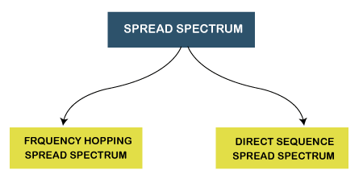

### **Frequency Hopping Spread Spectrum (FHSS):-**

When we transfer the data from sender to receiver than third party come to intrept in data and hack the data . so for avoid third party we use frequency hopping spread spectrum.

**HOPPING:-**  Hopping means It has different -different chanel to flow the data from sender to receiver . so if hacker want to intrept the data than he have to know about hopping sequence .

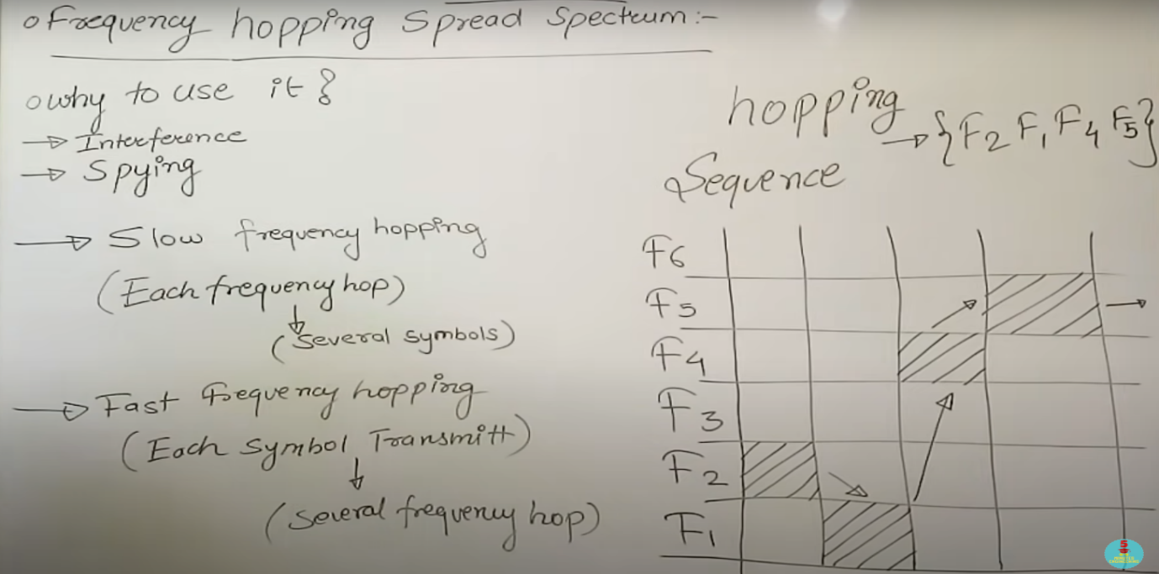

### **Direct Sequence Spread Spectrum (DSSS):-**

In DSSS use of spreading code(spreading code means 10 , 01 form) to avoid the intrept in communication between sender and receiver.

The Direct Sequence Spread Spectrum (DSSS) is a spread-spectrum modulation technique primarily used to reduce overall signal interference in telecommunication.

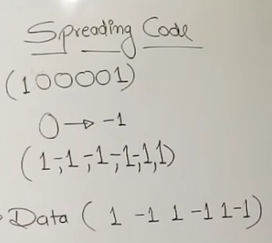

* In Direct Sequence Spread Spectrum or DSSS technique, the data that needs to be transmitted is split into smaller blocks.
* After that, each data block is attached with a high data rate bit sequence and is transmitted from the sender end to the receiver end.

**The Direct Sequence Spread Spectrum or DSSS can also be classified into two types:**

* Wide Band Spread Spectrum
* Narrow Band Spread Spectrum

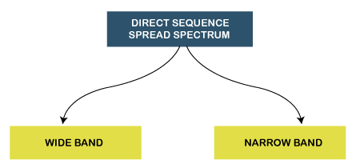

### **Advantages of Direct Sequence Spread Spectrum (DSSS):-**

* In Direct Sequence Spread Spectrum or DSSS, signals are challenging to detect.
* It provides the best discrimination against multipath signals.

### **Disadvantages of Direct Sequence Spread Spectrum (DSSS):-**

* It requires wide-band channels with small phase distortion.
* In DSSS, the pseudo-noise generator generates a sequence at high rates.

**UNIT :- 2**

# Error Detection & Correction:-

## **Types of Errors**

There may be three types of errors:

* **Single bit error**

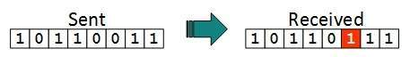

In a frame, there is only one bit, anywhere though, which is corrupt.

* **Multiple bits error**

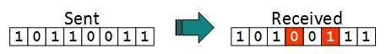

Frame is received with more than one bits in corrupted state.

* **Burst error**

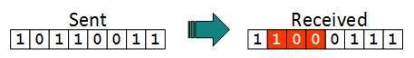

Frame contains more than1 consecutive bits corrupted.

## **Error Detection:-** Error Detection is detect the error that where have error aqure during sending and receiving data. So error detection tells that there error have aqure .

# Error Correction:-

# Error Correction is tell that there the error aqure in that bit . it is tells right error location after that it is fix the error of data.

* **LINE CODING:-**

# 

* **BLOCK CODING:-**

Block coding refers to **the technique of adding extra bits to a digital word in order to improve the reliability of transmission**.

**Block coding** helps in error detection and re-transmission of the signal. It is normally referred to as mB/nB coding as it replaces each m-bit data group with an n-bit data group (where n>m). Thus, its adds extra bits (redundancy bits) which helps in synchronization at receiver’s and sender’s end and also providing some kind of error detecting capability.

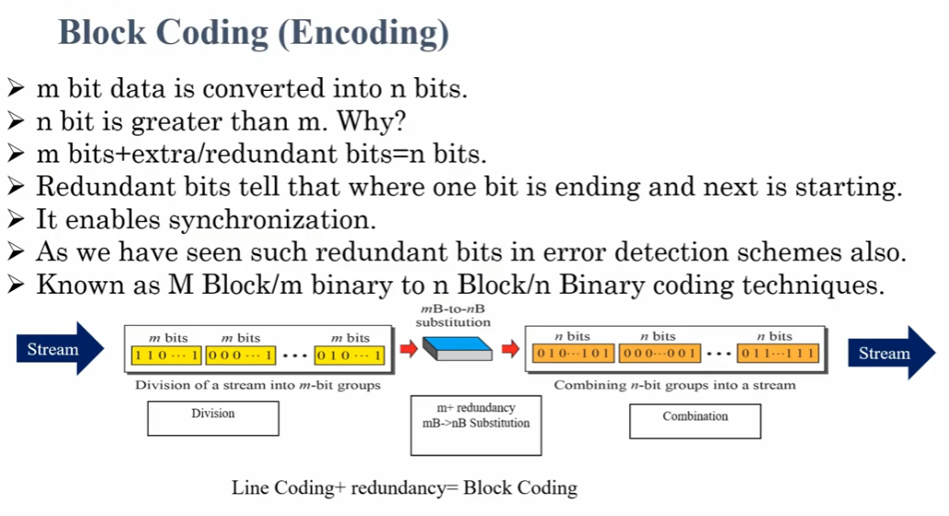

* **HAMMING DISTANCE:-**

Hamming distance is **a metric for comparing two binary data strings**. While comparing two binary strings of equal length, Hamming distance is the number of bit positions in which the two bits are different. The Hamming distance between two strings, a and b is denoted as d(a,b)

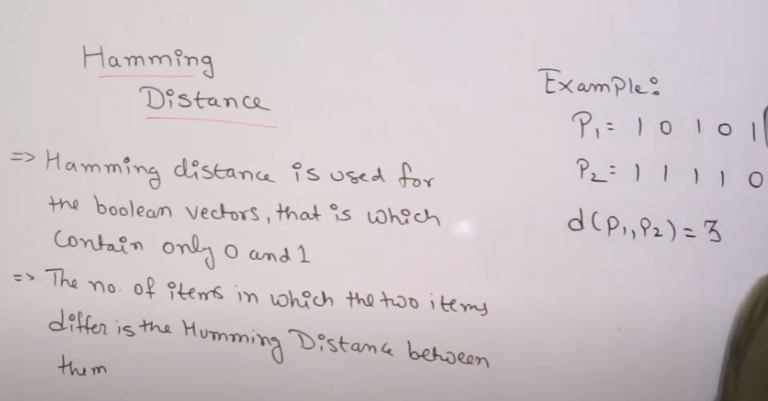

* **Flow control:-**

**Flow control** is [design issue at Data Link Layer](https://www.geeksforgeeks.org/design-issues-in-data-link-layer/). It is a technique that generally observes the proper flow of data from sender to receiver. It is very essential because it is possible for sender to transmit data or information at very fast rate and hence receiver can receive this information and process it. This can happen only if receiver has very high load of traffic as compared to sender, or if receiver has power of processing less as compared to sender. Flow control is basically a technique that gives permission to two of stations that are working and processing at different speeds to just communicate with one another.

## Flow control is a technique that allows two stations working at different speeds to communicate with each other.

## **Flow Control Techniques in Data Link Layer**

Data link layer uses feedback based flow control mechanisms. There are two main techniques −

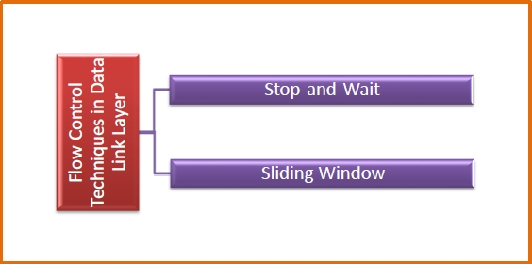

## **Stop and Wait:-**

This protocol involves the following transitions –

It is the simplest flow control method. In this, the sender will transmit one frame at a time to the receiver. The sender will **stop and wait** for the acknowledgement from the receiver.

This time (i.e. the time joining message transmitting and acknowledgement receiving) is the sender’s waiting time, and the sender is idle during this time.

When the sender gets the acknowledgement (ACK), it will send the next data packet to the receiver and wait for the disclosure again, and this process will continue as long as the sender has the data to send.

While sending the data from the sender to the receiver, the data flow needs to be controlled. If the sender is transmitting the data at a rate higher than the receiver can receive and process it, the data will get lost.

* The sender sends a frame and waits for acknowledgment.
* Once the receiver receives the frame, it sends an acknowledgment frame back to the sender.
* On receiving the acknowledgment frame, the sender understands that the receiver is ready to accept the next frame. So it sender the next frame in queue.

# Go-Back-N ARQ:-

* It is the flow control method. In this, the sender will transmit multiple frame at a time to the receiver but receiver receive one frame at a time. The sender will **stop and wait** for the acknowledgement from the receiver.

When the sender gets the acknowledgement (ACK), it will send the next data packet to the receiver and wait for the disclosure again, and this process will continue as long as the sender has the data to send.

## **SELECTIVE REPEATER ARQ:-**

* It is the flow control method. In this, the sender will transmit multiple frame at a time to the receiver and receiver receive all frame at a time. The sender will **stop and wait** for the acknowledgement from the receiver.

In this sender gets the acknowledgement (ACK) of all frame at one time.

* **Sliding Window**

This protocol improves the efficiency of stop and wait protocol by allowing multiple frames to be transmitted before receiving an acknowledgment.

The working principle of this protocol can be described as follows −

* Both the sender and the receiver has finite sized buffers called windows. The sender and the receiver agrees upon the number of frames to be sent based upon the buffer size.
* The sender sends multiple frames in a sequence, without waiting for acknowledgment. When its sending window is filled, it waits for acknowledgment. On receiving acknowledgment, it advances the window and transmits the next frames, according to the number of acknowledgments received.

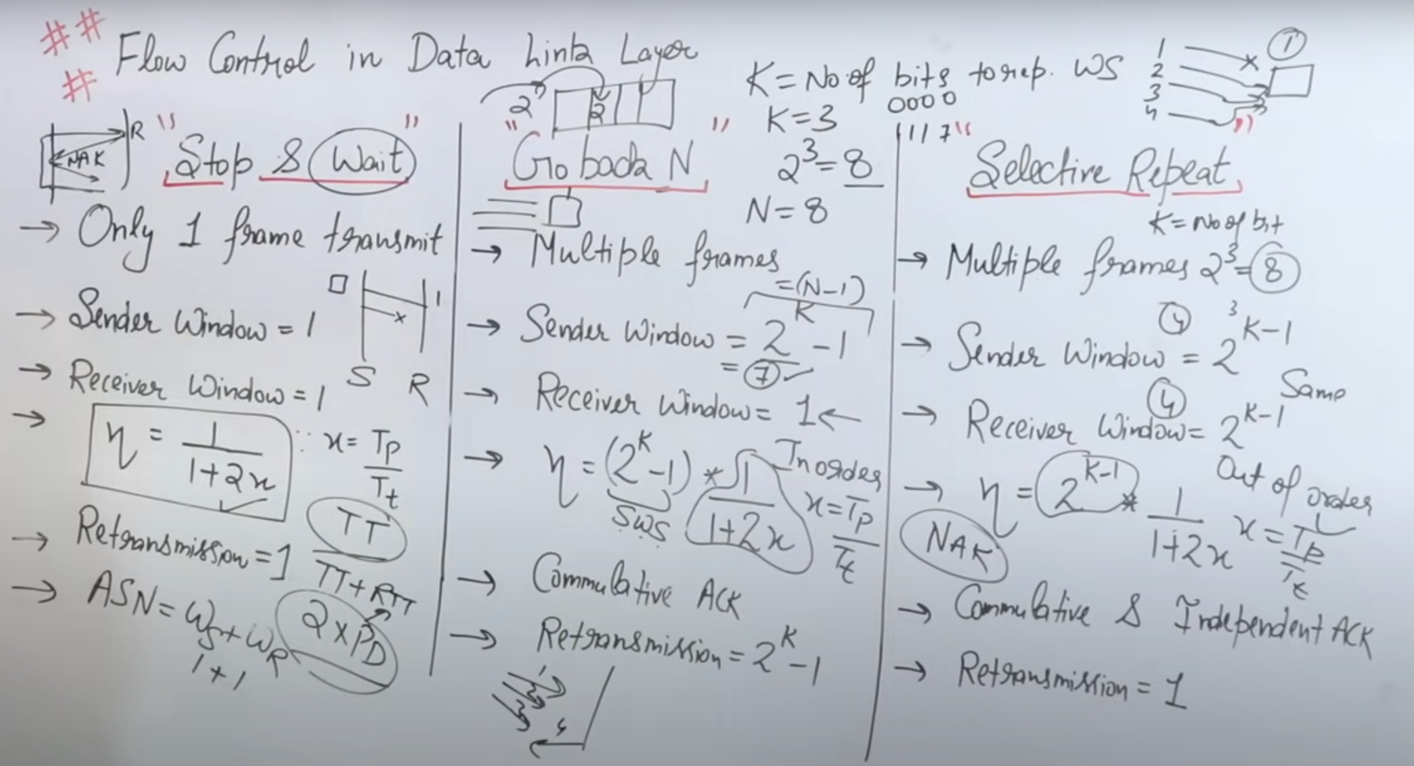

#### **Piggybacking:-**

* Piggybacking is a method of **attaching acknowledgment to the outgoing data packet**. The concept of piggybacking is explained as follows:
* Consider a two-way transmission between host **A**and host **B**. When host A sends a data frame to B, then B does not send the acknowledgment of the frame sent immediately. The acknowledgment is delayed until the next data frame of host B is available for transmission. The delayed acknowledgment is then attached to the outgoing data frame of B. This process of delaying acknowledgment so that it can be attached to the outgoing frame is called **piggybacking**.
* 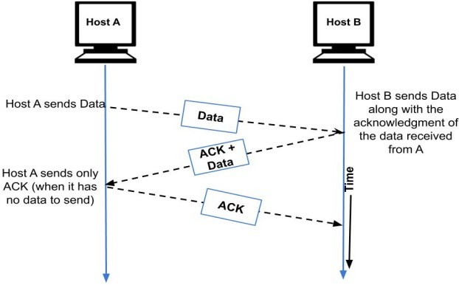

#### **Advantages of Piggybacking:-**

1. The available channel bandwidth is used efficiently.

#### **Disadvantages of Piggybacking:-**

1. There is additional complexity for implementing this method.

# Multiple Access Protocols :-

# Multiple access protocols are a set of protocols operating in the Medium Access Control sublayer (MAC sublayer) of the Open Systems Interconnection (OSI) model. These protocols allow a number of nodes or users to access a shared network channel. Several data streams originating from several nodes are transferred through the multi-point transmission channel.

## **Categories of Multiple Access Protocols**

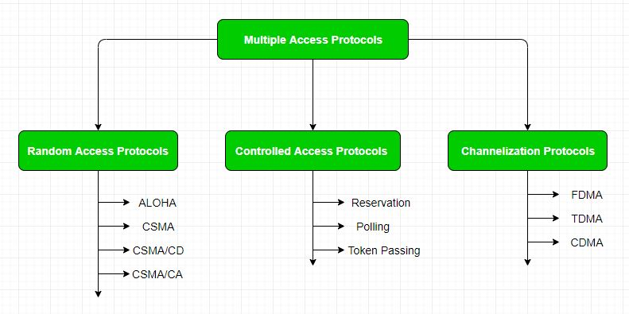

* **RANDOM ACESS:-**

## **Random Access Protocols**

Random access protocols assign uniform priority to all connected nodes. Any node can send data if the transmission channel is idle. No fixed time or fixed sequence is given for data transmission.

The four random access protocols are−

* ALOHA
* Carrier sense multiple access (CMSA)
* Carrier sense multiple access with collision detection (CMSA/CD)
* Carrier sense multiple access with collision avoidance (CMSA/CA)

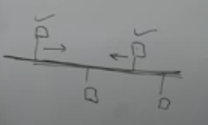

When two node will be send the data at a same time than collision will be occur.

* **ALOHA:-**
* ALOHA is a multiple access protocol for transmission of data via a shared network channel. It operates in the medium access control sublayer (MAC sublayer) of the open systems interconnection (OSI) model. Using this protocol, several data streams originating from multiple nodes are transferred through a multi-point transmission channel.
* In ALOHA, each node or station transmits a frame without trying to detect whether the transmission channel is idle or busy. If the channel is idle, then the frames will be successfully transmitted. If two frames attempt to occupy the channel simultaneously, collision of frames will occur and the frames will be discarded.

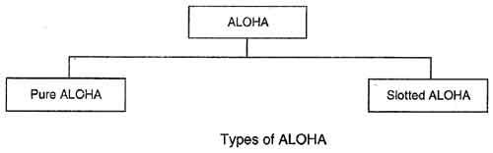

# Differences between Pure and Slotted Aloha

| * Pure Aloha | * Slotted Aloha |
| --- | --- |
| * In this Aloha, any station can transmit the data at any time. | * In this, any station can transmit the data at the beginning of any time slot. |
| * In this, The time is continuous and not globally synchronized. | * In this, The time is discrete and globally synchronized. |
| * Vulnerable time for Pure Aloha = 2 x Tt | * Vulnerable time for Slotted Aloha = Tt |
|  |  |
| * In Pure Aloha, Maximum efficiency   = 18.4% | * In Slotted Aloha, Maximum efficiency   = 36.8% |
| * Pure Aloha doesn’t reduces the number of collisions to half. | * Slotted Aloha reduces the number of collisions to half and doubles the efficiency of Pure Aloha. |
|  |  |
|  |  |
| . | . |
|  |  |
| |  |  | | --- | --- | |  |  | |  |

# Carrier Sense Multiple Access (CSMA):-

CSMA (carrier sense multiple access) is a process to send the data from one node to another node but before sending the data carrier sense will check the path that any other data is transferring or not . if no one data is transfer on path the carrier sense transfer the data. But it does not check entire path it`s check only self node.

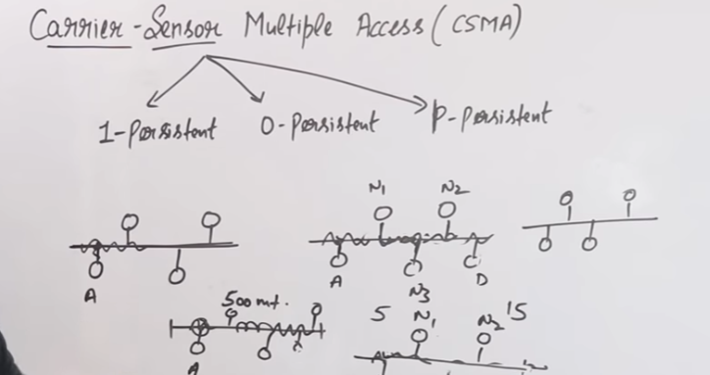

# Carrier Sense Multiple Access with COLLISION DETECTION(CSMA/CD):-

This technique is use to know that where is my data collise. It is detect that there your data have collide.

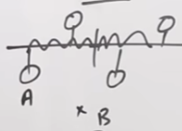

**UNIT – 3:-**

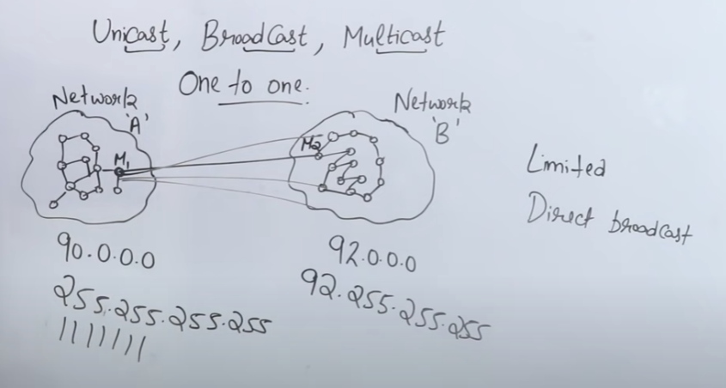

* **SWICHING:-**

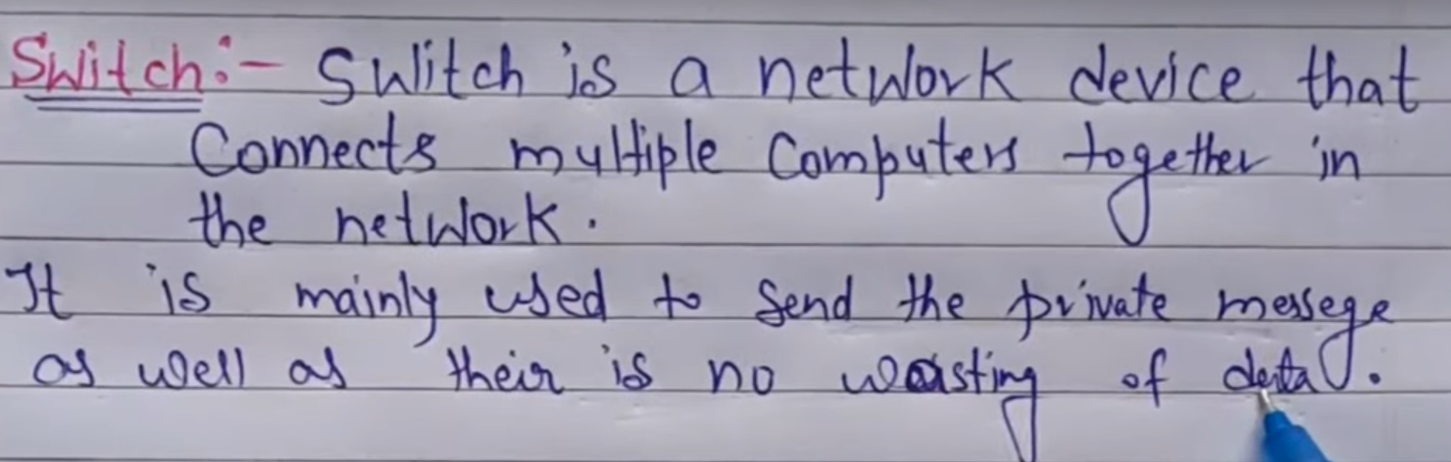

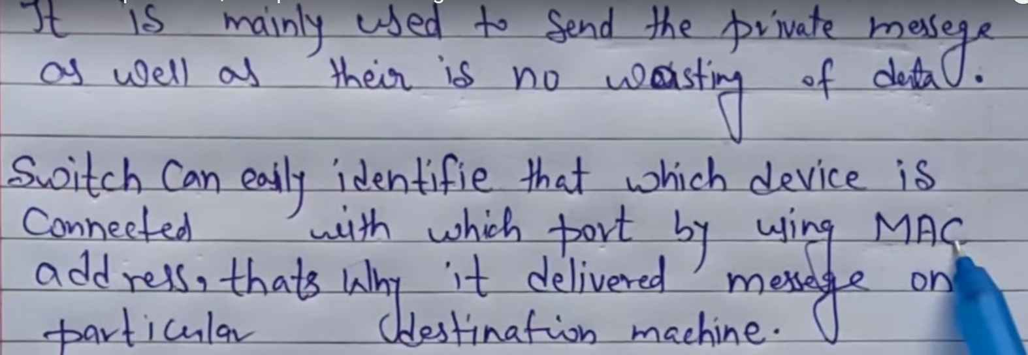

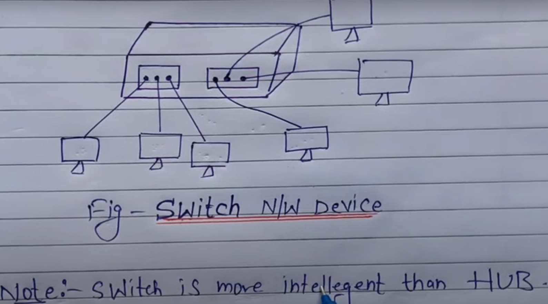

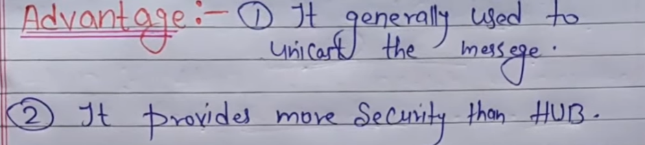

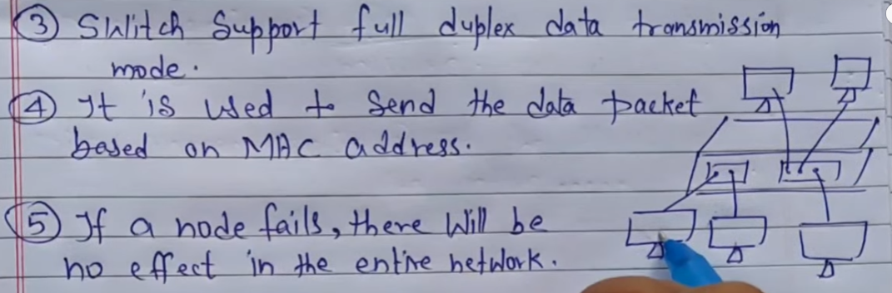

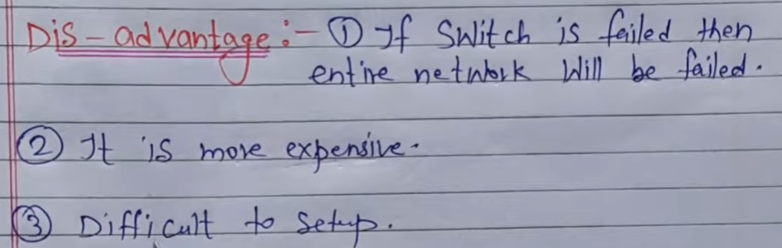

* **HUB:-**

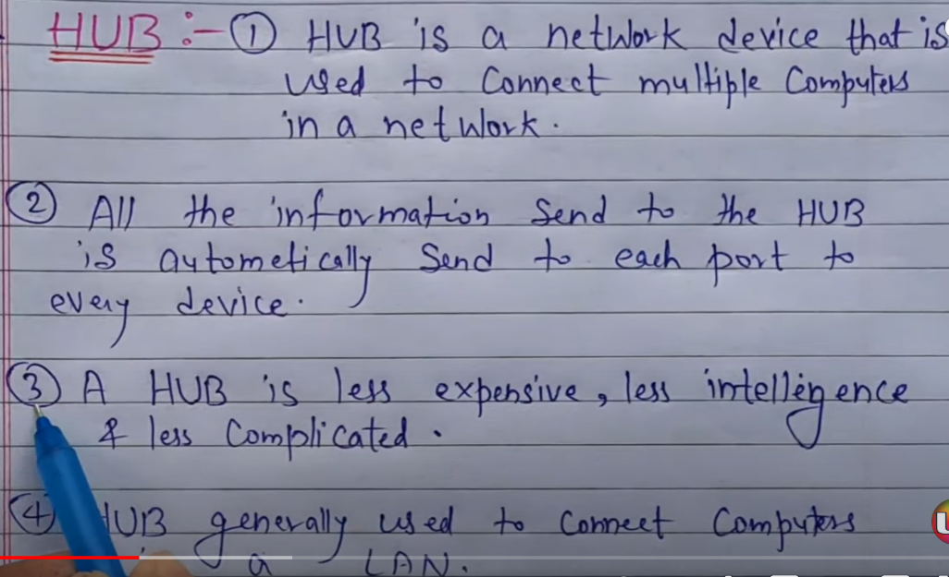

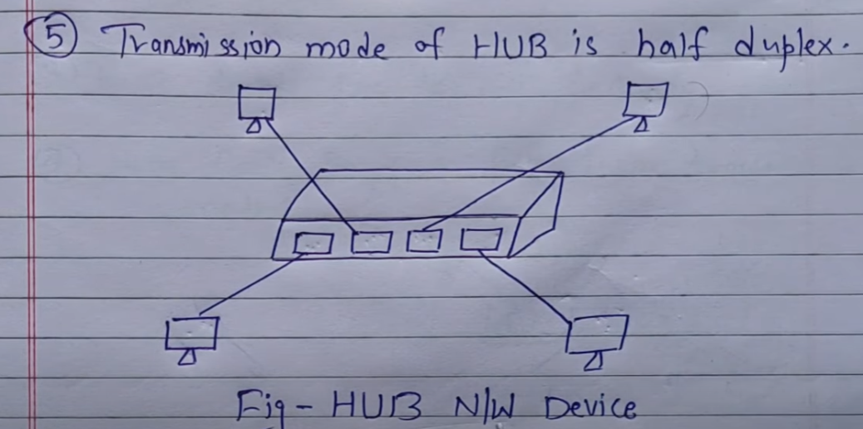

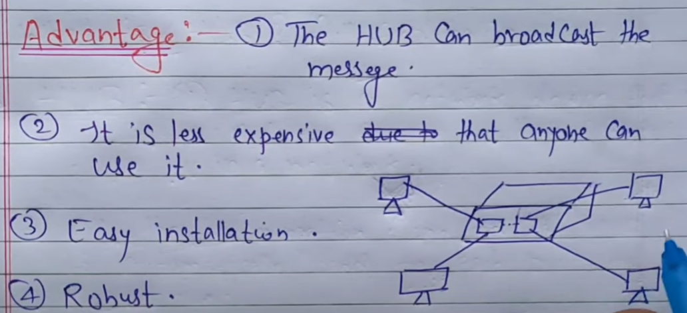

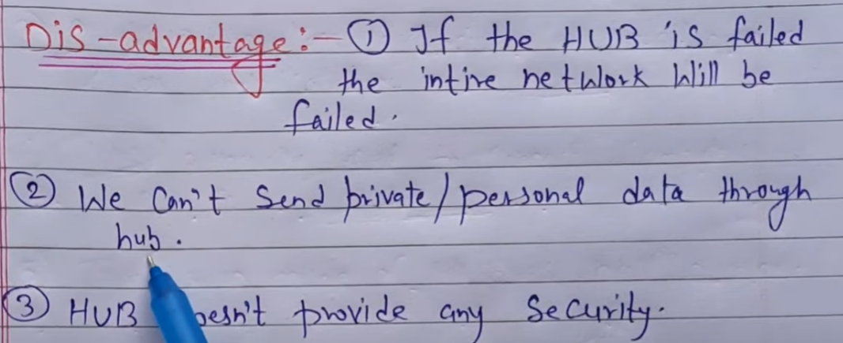

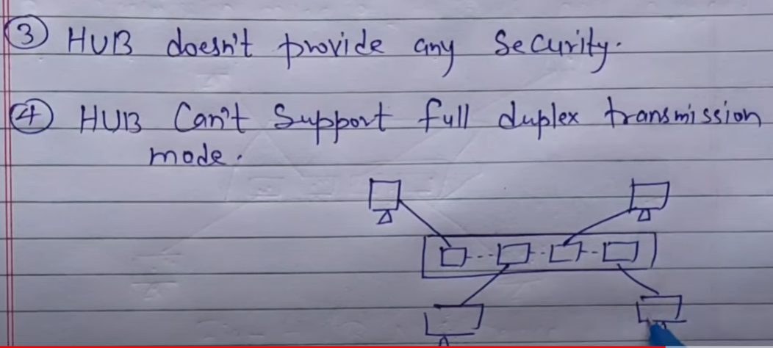

* **Router:-**

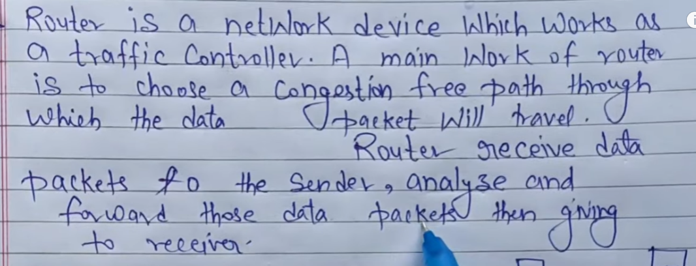

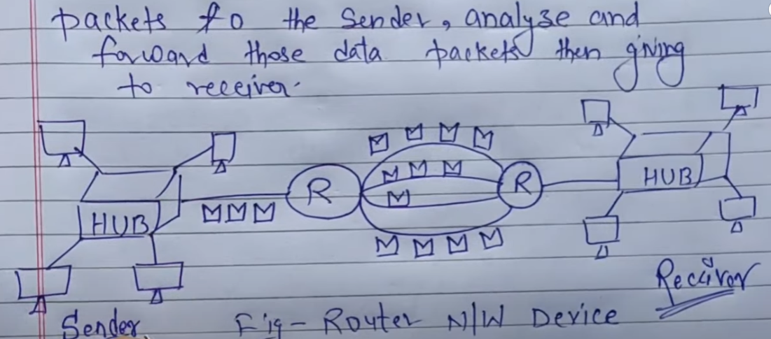

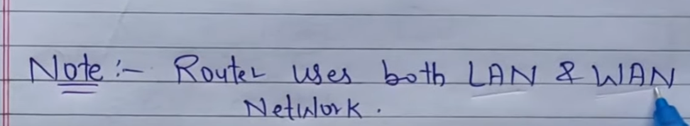

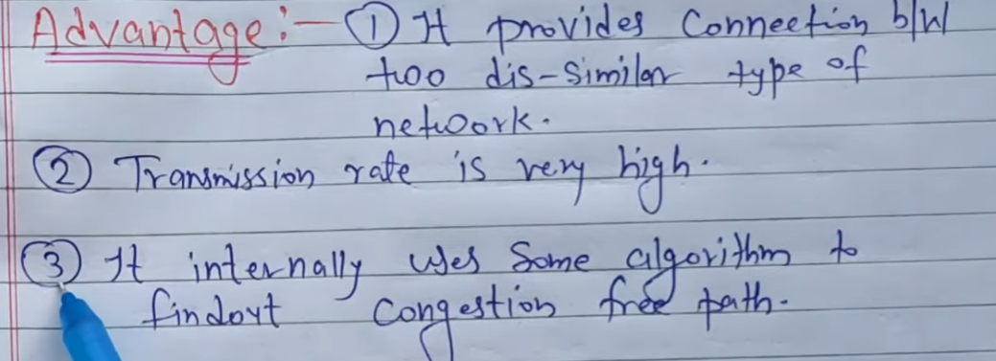



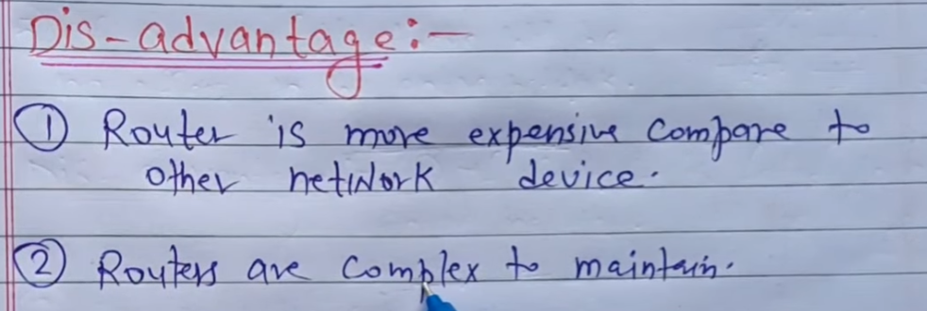

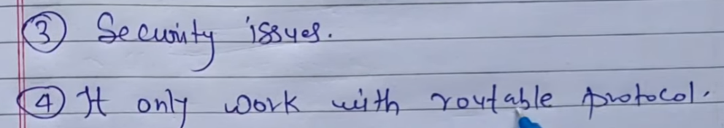

* [**IPAddress**](https://www.geeksforgeeks.org/difference-between-ip-address-and-port-number/)**:**  
  An Internet Protocol address is an IP address. It is a unique address that identifies the device on the network. The Internet Service Provider (ISP) assigns IP addresses to all devices on its network. IP addresses are not generated at random. The Internet Assigned Numbers Authority (IANA), a part of the Internet Corporation for Assigned Names and Numbers (ICANN), generates and assigns them mathematically . IP addresses are used at the network layer. IP Addresses are routable in nature.

**IP-Version-Types :**  
There are 2 different versions of IP as follows.

1. [**IPv4-(IP-version4)**](https://www.geeksforgeeks.org/introduction-and-ipv4-datagram-header/)**–**  
   IPv4 employs a 32-bit address. It is composed of four numbers separated by a ‘dot’ i.e., periods called an octet (byte). Each number in the octet can range from 0 to 255.  
   **Example –**172.166.3.28
2. [**IPv6-(IP-version-6)**](https://www.geeksforgeeks.org/internet-protocol-version-6-ipv6/)**–**  
   IPv6 is the next generation of Internet Protocol addresses. In comparison to IPV4, IPv6 has a larger address space. IPv6 has a length of 128 bits and is written in hexadecimal. It is composed of eight fields, each of which contains two octets. As a result, IPv6 has 16-octets-intotal.  
   **Example –** 3221:1cd7:74b6:6da7:0000:0000:7349:6472

* **Address mapping:-**

Address mapping is used to describe the physical address.

It describe the address from logical to physical and also physical to logical.

### **1. Address Resolution Protocol (ARP) –**

Address Resolution Protocol is a communication protocol used for discovering physical address associated with given network address. Typically, ARP is a network layer to data link layer mapping process, which is used to discover MAC address for given Internet Protocol Address.

This protocol have IP address but It does not have MAC address so it`s use for find MAC address.

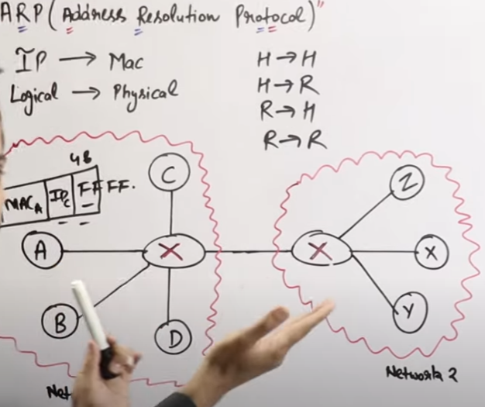

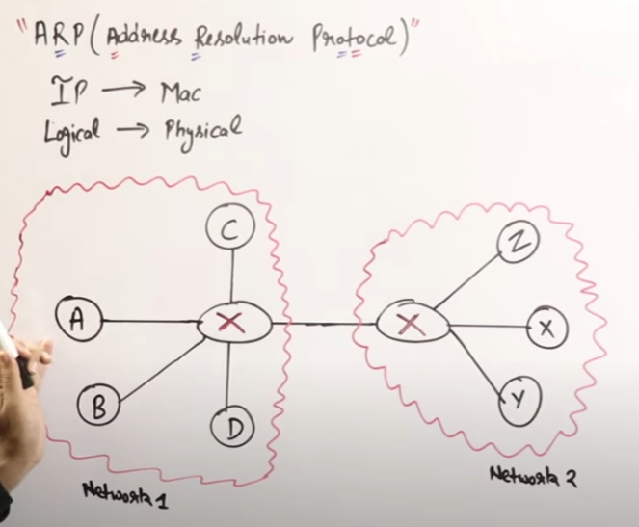

### **Reverse Address Resolution Protocol (RARP) –**

* Reverse Address Resolution Protocol is a communication protocol used for discovering Logical address associated with given network address. Typically, RARP is a network layer to data link layer mapping process, which is used to discover IP address for given Internet Protocol Address.

This protocol have MAC address but It does not have IP address so it`s use for find IP address.

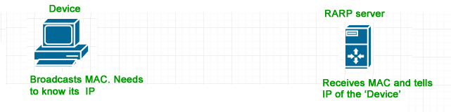

* [**Bootstrap Protocol (BOOTP)**](https://www.geeksforgeeks.org/difference-between-bootp-and-dhcp/):-is a networking protocol which is used by networking administration to give IP addresses to each member of that network for participating with other networking devices by the main server.

Bootp(Bootstrap protocol) start when we strat computer booting It is help to connect with IP address over network. It is a broadcast network.

**Dynamic Host Configuration Protocol (DHCP):-**

Dynamic Host Configuration Protocol (DHCP) is a client/server protocol that automatically provides an Internet Protocol (IP) host with its IP address and other related configuration information such as the subnet mask and default gateway.

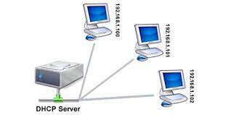

* **DELIVERY:-**

Delivery is use to deliver the netware between host or device.

* **Type of Delivery:-**

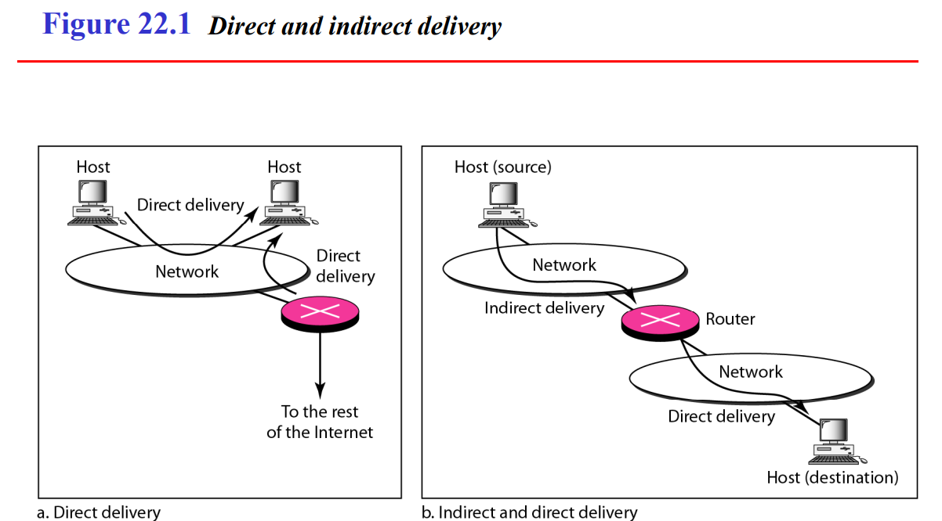

* **FORWARDING:-**

Forwarding means we forward the data and internet at crect location.

* **UNICAST ROUTING PROTOCOLS ¬**

A routing table can be either static or dynamic. ¬ A static table is one with manual entries. ¬ A dynamic table is one that is updated automatically when there is a change somewhere in the Internet. ¬ A routing protocol is a combination of rules and procedures that lets routers in the Internet inform each other of changes.

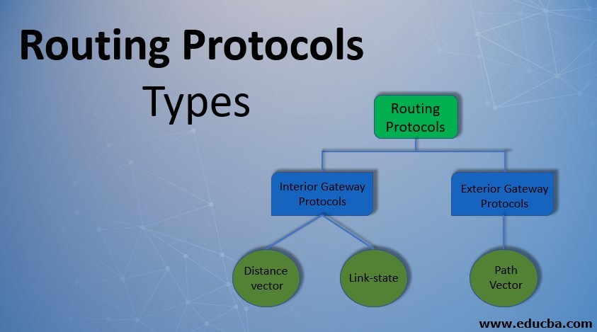

* **UNIT-4**

# Transport Layer responsibilities:-

Transport Layer is the second layer in the [TCP/IP model](https://www.geeksforgeeks.org/tcp-ip-model/) and the fourth layer in the [OSI model](https://www.geeksforgeeks.org/layers-of-osi-model/). It is an **end-to-end** layer used to deliver messages to a host. It is termed an end-to-end layer because it provides a point-to-point connection **rather than** hop-to- hop, between the source host and destination host to deliver the services reliably. The unit of data encapsulation in the Transport Layer is a segment.Transport layer user two(2) protocols TCP/IP and UDP Protocol.

## **What is TCP**

TCP is a transport layer connection-oriented protocol. It provides a reliable connection and protected data transmission between the connected machines over a network. It first establishes a secure link and then sends the data.

TCP sends the data from one device to the other in the form of data blocks. It is slow in data transmission but has more functionalities such as flow control, error control, and congestion control in the system.

The TCP header is of 20–60 bytes and therefore, it contains several pieces of information to improve the reliability.

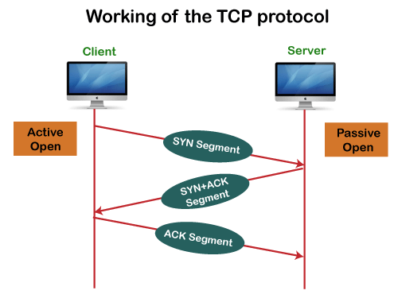

## **What is UDP**

UDP is a transport layer, connectionless protocol. It provides quick transmission of data between the connected machines over a network. There is no overhead of creating, maintaining, and terminating a connection in UDP.

It is mainly used to transmit real-time data where we cannot afford any transmission delays. UDP sends the data from one device to the other in the form of continuous data streams.

The UDP header is of fixed size, i.e., 8 bytes. It is unreliable but faster in speed. Due to its transmission speed, protocols like DNS, DHCP, RIP, etc., use UDP for proper data transmission over the network

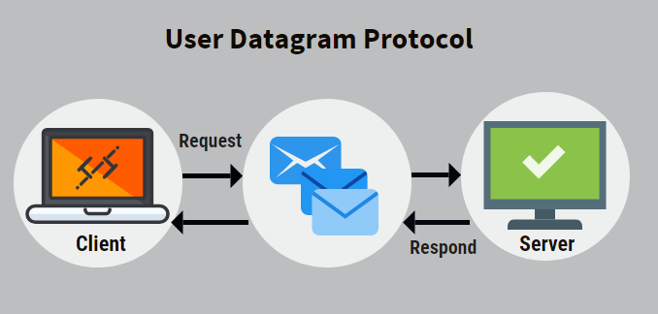

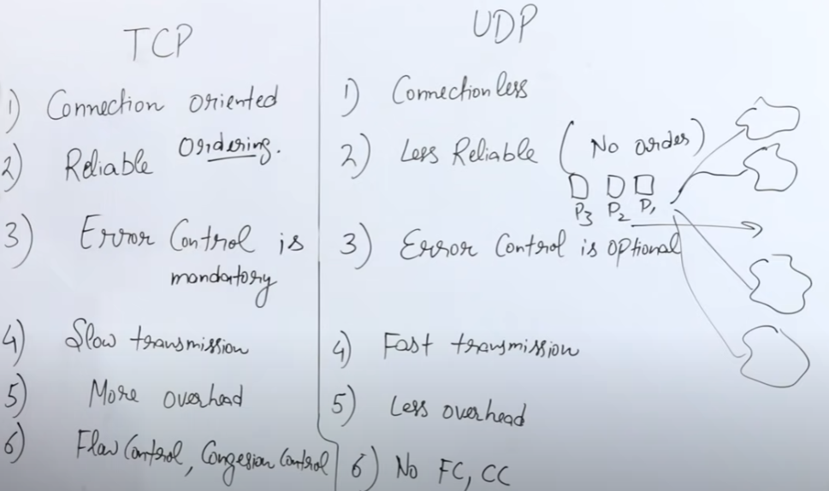

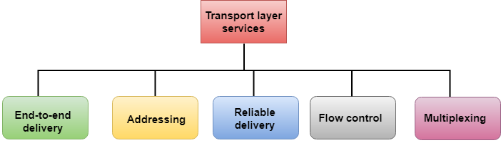

### **Working of Transport Layer:-**

The transport layer takes services from the [Network layer](https://www.geeksforgeeks.org/network-layer-services-packetizing-routing-and-forwarding/) and provides services to the [Application layer](https://www.geeksforgeeks.org/application-layer-in-osi-model/)

**At the sender’s side:**The transport layer receives data (message) from the Application layer and then performs Segmentation, divides the actual message into segments, adds source and destination’s port numbers into the header of the segment, and transfers the message to the Network layer.

**At the receiver’s side:**The transport layer receives data from the Network layer, reassembles the segmented data, reads its header, identifies the port number, and forwards the message to the appropriate port in the Application layer.

## **TCP/IP Model:-**

**TCP/IP Model** helps you to determine how a specific computer should be connected to the internet and how data should be transmitted between them. It helps you to create a virtual network when multiple computer networks are connected together. The purpose of TCP/IP model is to allow communication over large distances.

TCP/IP stands for Transmission Control Protocol/ Internet Protocol.

## **Four Layers of TCP/IP model:-**

* Application Layer
* Transport Layer
* Internet Layer
* Network Interface

## **Application Layer**

Application layer interacts with an application program, which is the highest level of OSI model. The application layer is the OSI layer, which is closest to the end-user. It means the OSI application layer allows users to interact with other software application.

Application layer interacts with software applications to implement a communicating component. The interpretation of data by the application program is always outside the scope of the OSI model.

* **TRANSPORTETION LAYER:-**
* Transport Layer is the second layer in the [TCP/IP model](https://www.geeksforgeeks.org/tcp-ip-model/) and the fourth layer in the [OSI model](https://www.geeksforgeeks.org/layers-of-osi-model/). It is an **end-to-end** layer used to deliver messages to a host. It is termed an end-to-end layer because it provides a point-to-point connection **rather than** hop-to- hop, between the source host and destination host to deliver the services reliably. The unit of data encapsulation in the Transport Layer is a segment.Transport layer user two(2) protocols TCP/IP and UDP Protocol.

## **Internet Layer**

An internet layer is a second layer of TCP/IP layes of the TCP/IP model. It is also known as a network layer. The main work of this layer is to send the packets from any network, and any computer still they reach the destination irrespective of the route they take.

## **Network Interface Layer**

Network Interface Layer is this layer of the four-layer TCP/IP model. This layer is also called a network access layer. It helps you to defines details of how data should be sent using the network.

* **Process to Process Delivery:-**

The data link layer is responsible for delivery of frames between two neighboring nodes over a link. This is called node-to-node delivery. The network layer is responsible for delivery of datagrams between two hosts. This is called host-to-host delivery. Real communication takes place between two processes (application programs). We need process-to-process delivery. The transport layer is responsible for process-to-process delivery-the delivery of a packet, part of a message, from one process to another. Figure 4.1 shows these three types of deliveries and their domains

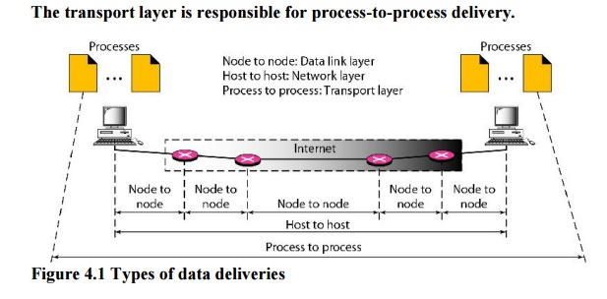

* **SCTP stands for Stream Control Transmission Protocol**.

It is a connection- oriented protocol in computer networks which provides a full-duplex association i.e., transmitting multiple streams of data between two end points at the same time that have established a connection in network. It is next generation of TCP or TCPng, SCTP makes it easier to support telephonic conversation on Internet. A telephonic conversation requires transmitting of voice along with other data at the same time on both ends, SCTP protocol makes it easier to establish reliable connection.

## **SCTP Services:-**

**Some important services provided by SCTP are as stated below:**  
  
**1. Process-to- Process communication**  
SCTP  uses all important ports of TCP.  
  
**2. Multi- Stream Facility**  
SCTP provides multi-stream service to each connection, called as association. If one stream gets blocked, then the other stream can deliver the data.  
    
**3.Full- Duplex Communication**  
SCTP provides full-duplex service ( the data can flow in both directions at the same time).  
  
**4. Connection- Oriented Service**  
The **SCTP** is a connection oriented protocol, just like TCP with the only difference that, it is called **association in SCTP**. If User1 wants to send and receive message from user2, the steps are :  
  
**Step1:** The two **SCTPs** establish the connection with each other.  
**Step2:** Once the connection is established, the data gets exchanged in both the directions.  
**Step3:** Finally, the association is terminated.  
  
**5. Reliability**  
SCTP uses an acknowledgement mechanism to check the arrival of data.

* **QOS(Quality Of Service):-**

QOS is a Technic to improve the services of software.

**There is 5 technic to improve Quality of services:-**

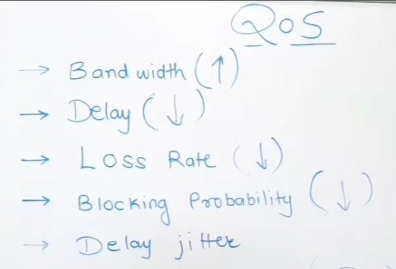

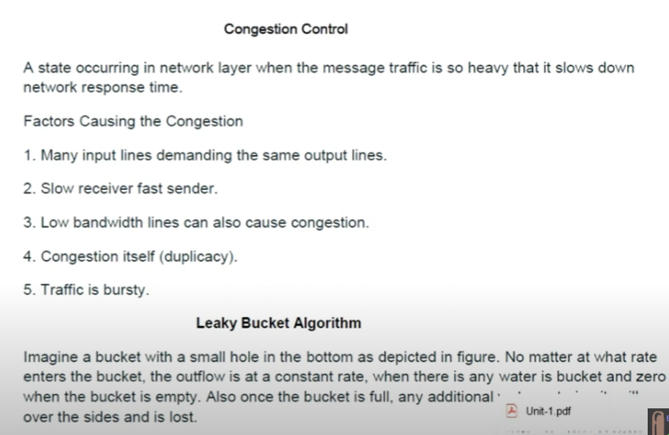

* **LEAKY BUCKET:-**

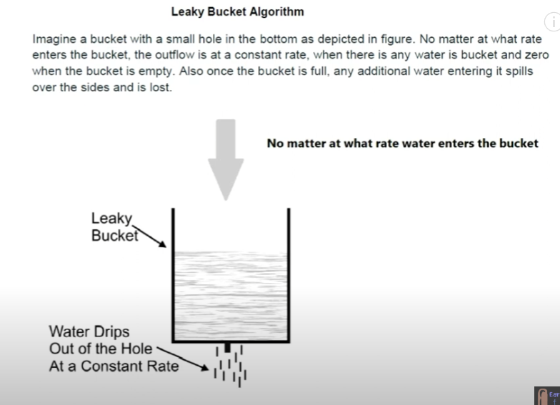

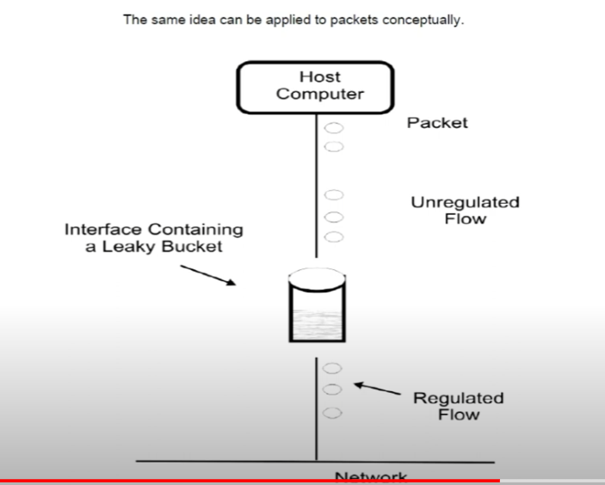

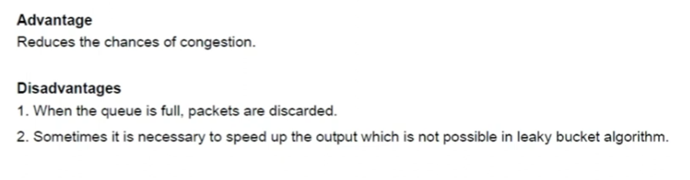

* **TOKEN BUCKET ALGORITHM:-**

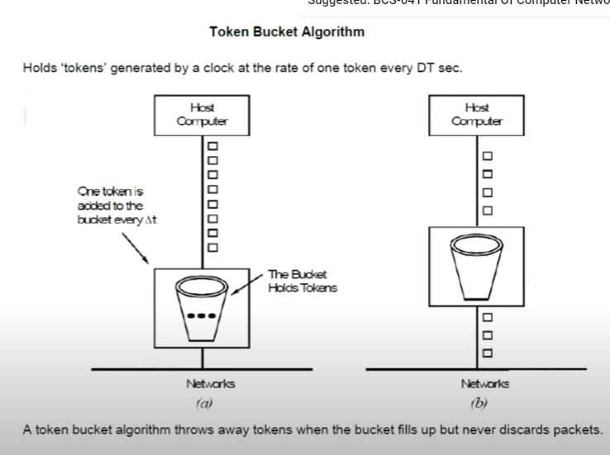

**UNIT :- 5**

* **Domain Name System(DNS):-**

DNS is a hostname for IP address translation service. DNS is a distributed database implemented in a hierarchy of name servers. It is an application layer protocol for message exchange between clients and servers.

**Requirement:** Every host is identified by the IP address but remembering numbers is very difficult for the people also the IP addresses are not static therefore a mapping is required to change the domain name to the IP address. So DNS is used to convert the domain name of the websites to their numerical IP address.

**Domain:** There are various kinds of DOMAIN:

1. Generic domain: .com(commercial) .edu(educational) .mil(military) .org(non profit organization) .net(similar to commercial) all these are generic domain.
2. Country domain .in (india) .us .uk
3. Inverse domain if we want to know what is the domain name of the website. Ip to domain name mapping. So DNS can provide both the mapping for example to find the ip addresses of geeksforgeeks.org then we have to type nslookup www.geeksforgeeks.org.

**Organization of Domain:**

[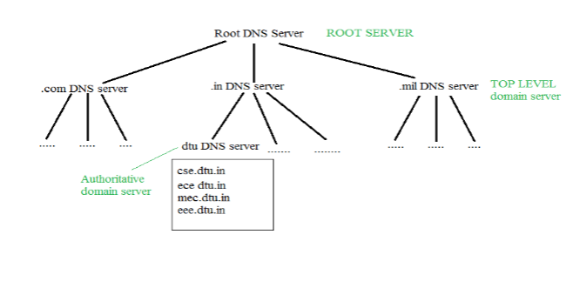](https://media.geeksforgeeks.org/wp-content/cdn-uploads/gq/2017/02/DNS.png)

**Dynamic Domain Name System (DDNS) :** It is a method of automatically updating a name server in the Domain Name Server (DNS), often in real-time, with the active DDNS configuration of its configured hostnames, addresses, or other information. In DDNS, when a binding between a name and an address is determined, the information is sent, usually by [DHCP (Dynamic Host Configuration Protocol)](https://www.geeksforgeeks.org/dynamic-host-configuration-protocol-dhcp/) to a primary DNS server. The primary server updates the zone. The secondary servers are notified either actively or passively. Inactive notification, the primary server sends a message to secondary servers, whereas, in the passive notification, the secondary servers periodically check for any changes. In either case, after being notified about the change, the secondary requests information about the entire zone (zone transfer). DDNS can use an authentication mechanism to provide security and prevent unauthorized changes in DNS records.

**Advantages :**

1. It saves time required by static addresses updates manually when network configuration changes.
2. It saves space as the number of addresses are used as required at one time rather than using one for all the possible users of the IP address.
3. It is very comfortable for users point of view as any IP address changes will not affect any of their activities.
4. It does not affect accessibility as changed IP addresses are configured automatically against URL’s.

**Disadvantages :**

1. It is less reliable due to lack of static IP addresses and domain name mappings.
2. Dynamic DNS services alone can not make any guarantee about the device you are attempting to connect is actually your own.

[**TELNET**](https://practice.geeksforgeeks.org/problems/explain-telnet)stands for**Tel**etype **Net**work. It is a type of protocol that enables one computer to connect to local computer. It is a used as a standard [**TCP/IP protocol**](https://www.geeksforgeeks.org/tcp-ip-in-computer-networking/) for virtual terminal service which is given by [**ISO**](https://www.geeksforgeeks.org/iso-full-form/). Computer which starts connection known as the**local computer**. Computer which is being connected to i.e. which accepts the connection known as **remote computer**. When the connection is established between local and remote computer. During telnet operation whatever that is being performed on the remote computer will be displayed by local computer. Telnet operates on client/server principle. Local computer uses telnet client program and the remote computers uses telnet server program.

**TELNET Commands :**   
Commands of the telnet are identified by a prefix character, Interpret As Command (IAC) which is having code 255. IAC is followed by command and option codes. Basic format of the command is as shown in the following figure :

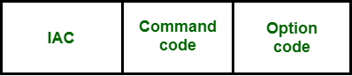

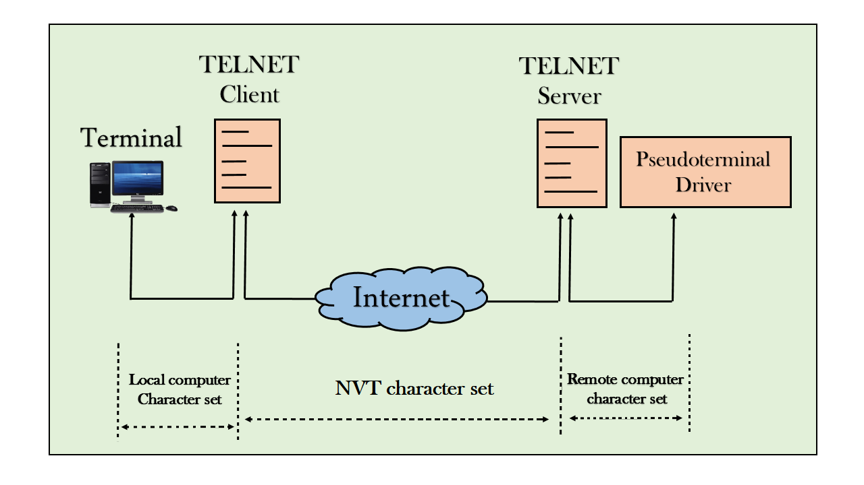

**Electronic Mail :-**(e-mail) is one of most widely used services of [Internet](https://www.geeksforgeeks.org/the-internet-and-the-web/). This service allows an Internet user to send a **message in formatted manner (mail)** to the other Internet user in any part of world. Message in mail not only contain text, but it also contains images, audio and videos data. The person who is sending mail is called **sender** and person who receives mail is called**recipient**. It is just like postal mail service.

**Components of E-Mail System :** -The basic components of an email system are : User Agent (UA), Message Transfer Agent (MTA), Mail Box, and Spool file.

**1.User Agent (UA) :** The UA is normally a program which is used to send and receive mail. Sometimes, it is called as mail reader.

**2.Message Transfer Agent (MTA) :** MTA is actually responsible for transfer of mail from one system to another. MTA is done by [Simple Mail Transfer Protocol](https://www.geeksforgeeks.org/simple-mail-transfer-protocol-smtp/).

**3.Mailbox :** It is a file on local hard drive to collect mails.

**4.Spool file :** This file contains mails that are to be sent.

# Firewalls:-

# A firewall is a network security device; it is a protective layer for the server that monitors and filters all the incoming and outgoing network traffic. It uses a set of rules to determine whether to allow or block a specific network traffic. Firewalls can prevent unauthorized use before reaching the servers. Firewalls can be hardware or software-based.

Packet flowing through a firewall can have one of the following three outcomes −

* **Accepted** − Permitted through the firewall.
* **Dropped** − Not allowed through with no indication of failure
* **Rejected** − Not allowed through accompanied by an attempt to inform the source that the packet was rejected.

## **Types of Firewall**

* **Packet Filters (Stateless Firewall)** − In the packet filters, if a packet matches then the packet filters set of rules and filters will drop or accept it.
* **Stateful firewall filters** − It is also known as a network firewall; this filter maintains a record of all the connections passing through. It can determine if a packet is either the start of a new connection or a part of an existing connection or is an invalid packet.
* **Application firewall** − A web application firewall is used for HTTP applications. There are sets of rules that are applied to monitor or block data packets from HTTP network traffic. For example, these rules can help block cross-site scripting (XSS) and SQL injections.

# Bluetooth:-

# It is a Wireless Personal Area Network (WPAN) technology and is used for exchanging data over smaller distances.

# Maximum devices that can be connected at the same time are 7. Bluetooth ranges up to 10 meters.

### Bluetooth Architecture:

The architecture of Bluetooth defines two types of networks:

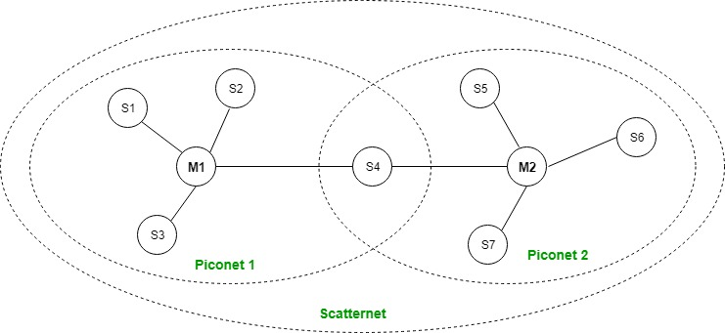

# SNMP:-

# SNMP stands for ****Simple Network Management Protocol****. It is an Internet-standard protocol for handling devices on IP networks. Devices that typically provide SNMP include routers, switches, servers, workstations, printers, modem racks, and more. It is used mainly in the network management framework to monitor network-attached computers for conditions requiring regulatory attention. It is use to manage the network.

# Cryptography:-

# Cryptography refers to the science and art of transforming messages to make them secure and immune to attacks. It is a method of storing and transmitting data in a particular form so that only those for whom it is intended can read and process it. Cryptography not only protects data from theft or alteration but can also be used for user authentication.

# 